

**COVENTRY LPU STOP & SEARCH DATA**

**BREAKDOWN OF STOP/SEARCH RECORDS FOR COVENTY LPU**

**25th MAY 2016 to 24th JUNE 2016**

**Contents**

Monthly Glidepath………………………………………………………………………………………………. 3

Coventry Stop & Search update ……………………………………...……………………………………. 3/4

LPU Crime/Searches Comparisons………………………………………………………………………… 5

Object/Purpose of search……………………………………………………………………………………….. 6

Powers……………………………………………………………………………………………………………………. 6

Outcomes……………………………………………………………………………………………………………….. 7

Positive Outcomes by LPU ………………………………………………………………………………………. 8

Ethnicity………………………………………………………………………………………………………………….. 9

Ethnicity by Age Group………………………………………………………………………………………………10/11

Demographics………………………………………………………………………………………………………… 12

Age Profiles ……………………………………………………………………………………………………………. 13

Female stops………………………………………………………………………………………………………….. 13

Aoristic Analysis……………………………………………………………………………………………………… . 14

Top Crime Locations & Search location maps………………………………………………………….. 15

Stop/Searches by Neighbourhood…………………………………………………………………………… 16

Ethnicity of stops by Neighbourhood…………………………………………………………………..…… 16

***The data contained in this report relates to a period 25th MAY to 24th JUNE***

**MONTHLY GLIDE PATH**

The above chart displays the monthly comparisons of Stop searches conducted broken down into the Police Powers utilised.

This period saw a decrease in the numbers of stop/searches conducted, down from 129 to 98.

This has continued the monthly, downward , trend in stop/searches conducted from the peak of 229 in February. There was a five month period between Dec 2015 & April 2016 where numbers were significantly higher. This correlated with the delivery of operations Cocktail & Fen, which were specific operations linked to the Misuse of drugs and carrying of weapons linked to the Night time economy. Since the conclusion of these operations levels have fallen back to the previous average of approximately 100 per month. The misuse of drugs Act was once again the most used power with 68 ( 69.4%)

**STOP AND SEARCH**

**UPDATE 25th May 2016 – 24th June 2016**

The total recorded stop searches for the period were **98**

These broke down to **74** individuals**, 20** individuals & vehicles and **4** Vehicle.

The data is accurate at the time of compiling this report but may change as retrospective records are entered.

This period total (**98)** this is again lower than last months 129 and has now reached the average level displayed prior to December 2015. The Law has now been implemented regarding “Legal Highs” and this has resulted in 3 stop/ searches concluding with the seizure of substances.

**LPU Crime/Stop Search Comparisons**

|  |  |  |  |  |  |  |  |  |  |
| --- | --- | --- | --- | --- | --- | --- | --- | --- | --- |
| SH | BN | DY | WS | WV | SW | BE | BS | CV | BWC |
| 715 | 791 | 1118 | 1208 | 1295 | 1428 | 1452 | 1498 | 1516 | 1853 |
|  |  |  |  |  |  |  |  |  |  |

During the period of this report Coventry recorded 1516 crimes and has again moved further up the table from last months 3rd position to second position this month This continues the Increases in Crime recorded on the LPU and despite all other LPU’s experiencing increases the percentile differential appears to be increasing more rapidly in Coventry.

|  |  |  |  |  |  |  |  |  |  |
| --- | --- | --- | --- | --- | --- | --- | --- | --- | --- |
| BS | DY | CV | SW | WV | SH | WS | BN | BE | BWC |
| 46 | 87 | 98 | 115 | 123 | 125 | 133 | 146 | 232 | 270 |

The numbers of stop searches conducted are contained in the above chart. Although this period saw Coventry record the second largest amount of crimes, the stop/searches conducted was at a level third smallest. This level is comparable with other LPU’s and suggests that searches are being currently intelligence led but also led by on-going incidents and there is little or no capacity to complete other searches. .

**OBJ** **ECT/PURPOSE**

There were **68** searches (**69.4%**) where the object suspected was drugs/illegal substances, **18** searches (**18.4%)** seeking to find stolen items , **4** searches (**4.1**%) concerned articles for burglary/theft/fraud and a further **1 (1.0%)** seeking to find articles for going equipped. There were **7 (7.1%)** searching for offensive weapons (including **2** firearms)

This is largely unchanged from previous reports with drugs remaining the predominant object in searches.

**POWERS**

Section 23 Misuse of Drugs Act was used on **68** occasions, **28** searches employed the power conferred by S1 PACE. In addition this period there were **2** searches under Firearms legislation.

The use of the powers was largely unchanged this period with the Misuse of drugs Act remaining the most used power.

**OUTCOMES**

The chart below illustrates that **37** stop/searches during this period (**39.4%)** achieved a positive disposal,. This figure incorporates **22** Arrests, **5** Cannabis Warnings, **1** x Street summons, **2** Community Resolution, **3** Fixed Penalty & **3** Substances seized.

*(This percentage has been achieved by measuring* positive outcomes against searches of individuals only i.e. the 3 vehicles have been redacted. )

This year, so far, has seen significant monthly variations in positive outcomes. This is because the results can be affected by several uncontrollable factors such as when a group of individuals are stopped, particularly drugs related, they tend to generate a large number of records but even if drugs are found it is often not possible to attribute them to any individual, in which case all of the records culminate in a negative outcome, or if an offender is identified it is usually only 1 out of the group which means the remainder are recorded as negative outcomes. Continued controls around the documentary processes have resulted in a significant % increase this month which should, hopefully, be maintained.

Coventry has improved the positive outcomes this period and on average 1 in 3 stops result in a positive outcome compared to 1 in 4 last month. This has improved the standing and now falls broadly in line with the majority of other LPU’s.

There were 20 incidents where the stop involved more than 1 person (a total of 56 individuals). In 13 of these incidents positive action was taken against at least 1 member of the group resulting in 13 arrests, 3 Fixed penalties,3 substance seizures and 1 cannabis warnings.

.**BE** Birmingham East, **BN** Birmingham North, **BS** Birmingham South, **BWC** Birmingham West &Central, **SW** Sandwell, **DY** Dudley, **WS** Walsall, **WV** Wolverhampton, **CV** Coventry

**ETHNICITY**

**ETHNICITY PROFILE 25th May-24th June**

|  |  |
| --- | --- |
| White | 73.8% |
| Black | 5.6% |
| Asian | 16.3% |
| Mixed | 2.6% |
| Other | 1.7% |

|  |  |  |  |  |  |  |  |  |  |  |  |
| --- | --- | --- | --- | --- | --- | --- | --- | --- | --- | --- | --- |
| Age groups | White | Black | Asian | Mixed | Other | NS | TOT | Drugs | Pace | Terror | Firearms |
| 12& under |  |  |  |  |  |  | 0 |  |  |  |  |
| 13-15 | 12 | 1 |  | 2 |  |  | 15 | 14 | 1 |  |  |
| 16-20 | 10 | 3 | 9 | 2 |  |  | 24 | 14 | 10 |  |  |
| 21-25 | 7 | 2 | 9 | 2 |  |  | 20 | 16 | 3 |  | 1 |
| 26-30 | 10 | 1 | 2 | 2 | 0 | 1 | 16 | 12 | 4 |  | 1 |
| 31-35 | 5 | 1 |  |  |  |  | 6 | 3 | 3 |  |  |
| 36-40 | 3 |  | 2 |  |  |  | 5 | 4 | 1 |  |  |
| 41-45 | 1 |  | 1 |  |  |  | 2 | 2 |  |  |  |
| 46-50 |  |  |  |  |  |  | 0 |  |  |  |  |
| 51-55 | 1 |  |  |  |  |  | 1 |  | 1 |  |  |
| 56-60 | 1 |  |  |  |  |  | 1 |  | 1 |  |  |
| 60+ |  |  |  |  |  |  | 0 |  |  |  |  |
| NS |  |  |  |  |  | 4 | 4 | 2 | 2 |  |  |
| Totals | 50 | 8 | 23 | 8 | 0 | 5 | 94 | 67 | 26 | 0 | 2 |

There were **52**ndividuals **(51%)** of white ethnicity searched during this period, **23** individuals (**24.5**%) were of Asian ethnicity, **8** people (**8.5%)** were of African/Caribbean ethnicity and **8 (8.5%)** were mixed ethnicity. There were **4**incidents **(3.9%)**relating purely to vehicles with no individuals involved and therefore ethnicity did not apply or where ethnicity was not stated. and **1** individual**(1.0%)** who chose not to state their ethnicity but was identified by the officers as mixed race.

|  |  |  |  |  |  |
| --- | --- | --- | --- | --- | --- |
| **Ethnicity** | **No.s** | **%** | **Demographics** | **Should have been** | **Anomaly** |
| White | 50 | 54% | 73.80% | 72 | -22 |
| Black | 8 | 8.5% | 5.60% | 5 | 3 |
| Asian | 23 | 24.5% | 16.30% | 16 | 7 |
| Mixed | 10 | 10.6% | 2.60% | 3 | 7 |
| Other | 0 | 0.00% | 1.70% | 2 | -2 |
| NA | 4 | 3.92% |  |  |  |
| NS | 1 | 0.98% |  |  |  |

*\*The demography rates shown above are from the ONS website ( Dec 15)*.

This month shows a substantial disparity between searches conducted & demographics with an under recording of whites compared to over recording of other ethnic groups however it must be pointed out that the numbers involved are considerably low and there is known failings in the demographic data held which is outdated and inaccurate.

The **16-20 (24) & 21-25 (24)** age groups generated equal numbers this month and between them they accounted for **50%** of all stops.



The2 age groups combined were made up of , **17 (32.7%) White, 18** (**78.3%**) **Asian**, **5** (**62.5%** ) **Black**, **4** (**50%** ) **Mixed Race**

It can be clearly seen that these age groups account for 46% of all searches but are also responsible for thee overall ethnic disparity recorded this month.

There were no persons under the age of 12 stopped, again, this period; and **15** under the age of **16.** Only **15** (15%) persons stopped were over the age of 30.

The breakdown relating to ethnicity, Power & Outcome is contained in the following table:



1. Officers were called to a group of youths causing ASB . Upon arrival they found a group of 6 youths, 1 aged 16, 3 x 15 & 2 x 14. A strong smell of cannabis was evident and all were searched resulting in a quantity of drugs being recovered and 2 persons being arrested. Other illegal substances were also recovered from 2 other members of the group which were seized accordingly.
2. 4 youths ,aged 1 x 14, 2 x 15 & 1 x 16 ( including a female) were stopped after a report of drug dealing taking place all were searched with negative result.

.

The **15** youths stopped under the age of 16 were made up of, **12**  white ethnicity**, 2** were Mixed & **1** was Black . All, with the exception of 1 , were stopped for drugs and they resulted in 6 positive actions.

The oldest person stopped was aged **59** who was white, searched for stolen items as a result of a call received by police of a man acting suspiciously.. NFA’d when it was found that he was just going through bins. The only other person stopped over 50 was a White Male (53) who was believed to be involved in a number of crimes in the area. As a result of the search he was subsequently arrested.

**DEMOGRAPHICS**

The demographic data shown is as shown on the ONS website for December 2015

Coventry’s population stands at 337,400 with an ethnic breakdown as displayed below.

**City Demographics (ONS-Dec 2015)**

|  |  |
| --- | --- |
| White | 73.8% |
| Black | 5.6% |
| Asian | 16.3% |
| Mixed | 2.6% |
| Other | 1.7% |

**Age Demographics** *( as still shown on CCC website as December 2015)*

Of the persons searched during this period, **46.8%** (**44** persons) were aged between 16 and 25. The remaining were generally in the age groups either side 13-15 (15) & 26-30 (17) generating a further 43% .Which means that outside of these 4 age groups only generated just over 15% of stops

The youngest person stopped was aged **13yrs & 9 Months**  and the eldest **58yrs & 8 Months**

**FEMALE STOPS**

There were a total of **7** females stopped and searched during this period: (6 last period)

1 was described as Mixed-Other the remainder were all white with 6 being White-British and 1 White-Other.All were described as White and the age groups ranged between 15 & 31

**1 x aged 29** stopped together with a 33 year old male as a result of suspicious activity at Asda Brade drive where they were seen to secrete items around the store then leave before returning to the store and repeating this behaviour. Although property was recovered inside the store,nothing was found on either of them so they were NFA.

**1 x aged 16** was searched, together with 3 males aged 14&15 after a report of a male dealing drugs to teenagers at the location nothing was found and were all NFA.

**1 x aged28** was stopped in a vehicle together with a 23 yr old male as a result of information that the occupants were in possession of a firearm. Negative search result.

**2 x aged 26 & 31** were searched after a report from the public that drug smoking was taking place at the location.Negative result.

**1 x aged 28** searched after a report of person smoking drugs in bin shed at location. Drugs paraphanalia found but no illegal substances.

**1x aged 19** yrs who was believed to be seen on CCTV with her hand in an elderly ladies bag unfortunately the lady was so vulnerable that she was unable to identify if any of the property found on the person was hers or not so NFA.

None of the stops on females resulted in any formal action ,as described above

**AORISTIC ANALYSIS**

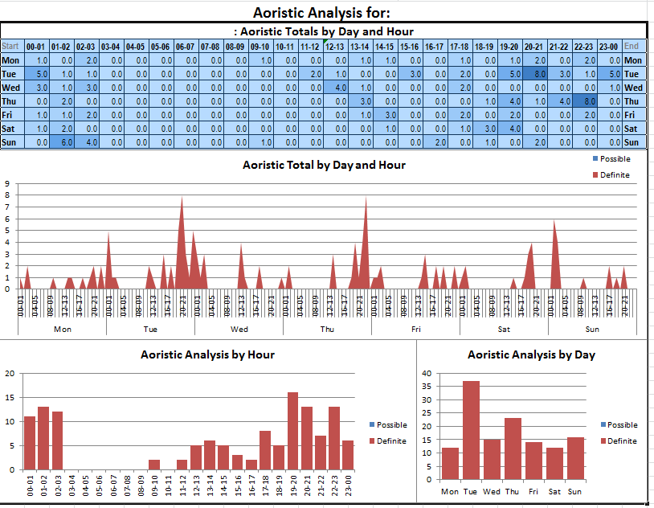

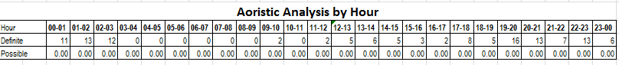

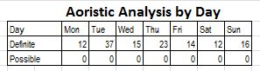

The above analysis shows that during this period the searches were pretty evenly spread although Tuesday appears to have generated double the amount of most other days. There doesn’t appear to be anything obvious in the data as to why Tuesdays should show an anomaly apart from the fact that half of them were conducted between 2300hrs & 0200hrs and most involved groups of several persons.

**24th June-25th July**

**STOP SEARCHES FOR PERIOD**

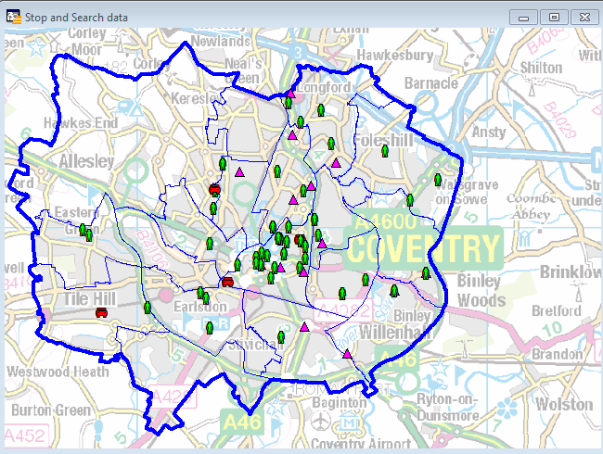

|  |  |  |
| --- | --- | --- |
| Individuals |  | 74 |
| Persons & Vehicles | | 20 |
| Vehicles |  | 4 |

**50 TOP CRIME LOCATIONS FOR THE PERIOD**

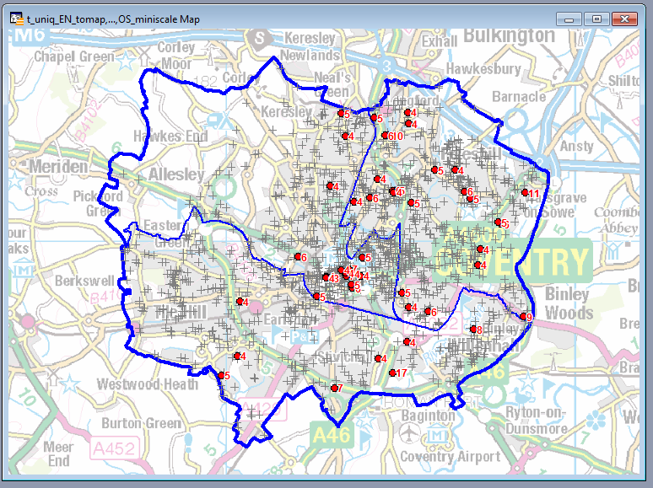

The above maps continue to demonstrate that the stop searches’ map is virtually a mirror image of the top crime locations indicating that stop search is being conducted in the correct areas.

The above clearly indicates that the majority of stop searches are conducted in high crime areas.

**25th July-24th August**