Walsall Strategic Community Reference Group
Minutes of meeting held on Thursday 14 July 2016 at Walsall Civic Centre.
In attendance:
Nirmal Singh (NS) Sikh Forum
R K Mehmi (RM) SGRT Darlaston
Cllr Ken Ferguson (KF) Brownhills Councillor
Elizabeth Kardynal (EK) EWA CIC
Cllr Rose Burley (RB) Councillor Bentley and Darlaston North
Ashley Lovell (AL) Darlaston South & LBGT
Michelle Cummings (ML) Street Teams
Pav Kaur (PK) Street Teams
Richard Harris (RH) West Midlands Police
Kelly Monaghan (KM) Walsall Police
Kevin Pitt (KP) Walsall Police

The following attended the Civic Centre but were unable to gain entry due to lack of disabled access:
Teresa Brown
M M Sacha
Imran Sacha

Apologies:
Gary Moorcraft
Alison Davies
Peter Griffin
Gary Moorcraft
Julie Finch

With Walsall Police Station having been evacuated due to a potentially explosive device being taken in to the front office, the meeting was moved to the Partnerships Team Office in Walsall Civic Centre and therefore started later than anticipated.

Minutes of Last Meeting.
The minutes of the last meeting were read and accepted.

Procedural Justice
Inspector Richard Harris, who is currently attached to the WMP2020 team, gave a presentation on procedural justice (PJ), which is seen as a driver of police legitimacy. The Chief Constable, Dave Thompson has set up a new mission statement with the aim of improving trust and confidence and strengthening the concept of policing by consent.

As a driver of legitimacy, PJ involves four principles:

- Giving the people a voice.
- Police treating people with dignity and respect.
- Police neutrality.
- Building public trust and confidence in the police.
The team is currently looking at the current position, i.e. how PJ is implemented around the world and it’s success. One example given was of Queensland Police (Australia), where the law allows them to conduct random breath testing of motorists. This caused some hostility among the public until the police took the step of explaining what they were doing and why.

It is important that the public are involved in the project, especially in giving feedback and evaluating it’s impact. As WMP is currently going through some internal changes, it is not intended to implement the project until spring 2017.

It was acknowledged that procedural justice is not a particularly good name and so it is intended to change the name to something that better explains the project.

The project will be delivered over a number of years.

The meeting discussed how the project can affect the public’s perception of the police, how the police are ‘the police’ and not a brand, i.e. events in other parts of the world can affect people’s perception of WMP officers.

Complaints against the police would still go to Professional Standards Dept and IPCC if necessary.

It is also essential that both the public and police staff understand the internal changes being made by WMP, driven largely by budget cuts, and how this affects how the police interact with the public.

Walsall Street Teams.
Due to lack of facilities Pav and Michelle were unable to give their planned presentation, however they were able to explain how they work with young people up to the age of 24 on various projects. They also explained the CASE Project, working with black ethnic minority groups to dispel myths around Child Sexual Exploitation and challenge misconceptions.

They are also training people to spot the signs of CSE, e.g. shop and hotel staff.

EK praised the project which has worked with the Polish School.

Police Update
KM explained that there was not much to report since the last meeting, the move to Bloxwich was going as planned and that new Neighbourhood Policing teams would be in place by November, but would look much the same as now. They would still have a role in engaging with the public, e.g. holding police surgeries.

KP explained some changes to the police website, coming into effect during the autumn, known as Digital Experience for Citizens. These would allow the public to interact electronically with the police, e.g. reporting certain crimes and generating statements, feedback and progress reporting and understanding options, (i.e. signposting to various services).

KP also explained that the current VC Relay messaging system would shortly be replaced by a system based on Neighbourhood Alert, to be called ‘WM Now’. This two-way messaging system will eventually allow police officers and staff to update communities in real-time via mobile technology.

Stop and Search Scrutiny Panel
Due to lack of facilities and time it was decided not to proceed with the stop and search scrutiny. However KP had the following information available, which shows that stop and search numbers and distribution have changed little from previous meetings.

Walsall Stop and Search 1st April to the 14th July 2016

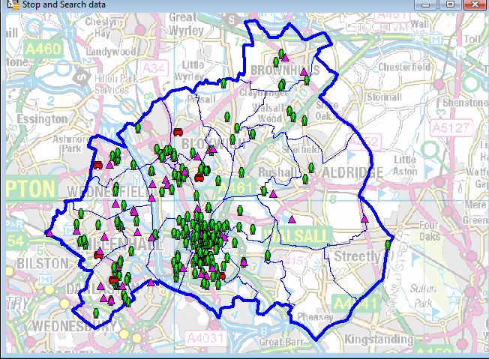

Group members expressed concern that hate crime is no longer discussed as an agenda item.

ACTION – KP to put hate crime back on the agenda and provide appropriate information at future meetings.

Questions were asked about the arson attack on the butcher’s shop in Wednesbury Road during June.

ACTION – KP to update group members on how the enquiry is progressing. (Done by email 18 July).

Any Other Business
There was no any other business.

Close and Date of Next Meeting.
The next meeting will be held on Thursday 15 September, 6pm, most likely at Bloxwich Police Station.

