Walsall Strategic Community Reference Group
Minutes of meeting held on Thursday 19 November 2015 at Walsall Police Station.
In attendance:
Cllr A Ditta (AD) Councillor Palfrey Ward
Bill Ellens (BE) CUSP
Cllr. Rose Burley (RB) Councillor Bentley/Darlaston North
Ken Ferguson (KF) Brownhills Committee
Ryan Steane (RS) Brownhills West Community Group
Nasar Iqbal (NI) Tell MAMA
Vasant Mistry (VM) Hindu Forum
Mr R K Mehmi (RM) SGRTD
Haroon Ravat (HR) Walsall MBC Cohesion Officer
Gary Moorcraft (GM) Citizens Advice Bureau
Martin Hurcomb (MH) Walsall Police
Kelly Monaghan (KM) Walsall Police
Gary Iliff (GI) Walsall Police
Bryn Robins (BR) West Midlands Police
Kevin Pitt (KP) Walsall Police

Apologies:
Nirmal Singh
Alison Davies
Peter Griffin
Sandeep Singh
Elizabeth Kardynal
Mr M M Sacha
Imran Sacha
Jo Clews
Andy Bullman

As the Chair, Mr Nirmal Singh, was absent the Chair was taken by Cllr Ditta.

The group held a minutes silence for victims of recent violence in Paris and elsewhere.

Minutes of Last Meeting.

The minutes of the last meeting held on 3 September were read and accepted.

Police Update.
In the light of the recent events in Paris MH gave an overview of the current terrorist threat. The national and local threat level has remained at severe – an attack is highly likely. WMP is taking extra steps to protect it’s staff and buildings. There has not been a rise in reported hate crime since the Paris attack, though there has been a small increase in the numbers of officers on uniformed patrol in Walsall to provide reassurance.

RB asked if today’s Queen’s visit had affected the number of officers available locally. MH replied that the event had been in the planning for some time and extra officers were on duty so no effect on the numbers in Walsall.

RM asked if there was an assessment around possible terrorists coming in from Syria and elsewhere. MH replied that there was much more concern about people being trafficked for employment and the sex trade. HR gave an example of supposedly ‘ISIS’ graffiti in Palfrey Park, Arabic writing falsely believed to be terrorist instruction/propaganda. The police and the council work together to identify possible terrorist-related graffiti.
NI added that the first cohort of upstanding neighbourhoods volunteers are now available.

Estates Update – MH explained that Bloxwich is still being emptied of staff who are moving to Walsall where they will be for around six months. Brownhills is now closing, Willenhall due to close next year.

The neighbourhood policing structure is being reviewed to put resources in places of greatest demand. This resource will be flexible.

RB asked about the situation with PCSO’s. MH answered that there will be a selection process to reduce the number to 119 over the next year.

ACTION – Put PCSO update on agenda for next meeting.

Performance – total recorded crime is up 4% this year to date which is mostly attributable to violent crime, particularly around domestic abuse. Walsall Police are the best in WMP for positive outcomes around domestic abuse. Most crime is still occurring in Walsall town centre.

Community Cohesion – Haroon Ravat, Walsall MBC
HR explained that his team is currently undertaking a consultation study around community cohesion with religious organisations, community groups and schools among others.

Stop and Search Update and Scrutiny

KP presented the following information.

Stop and Search for month of October 15
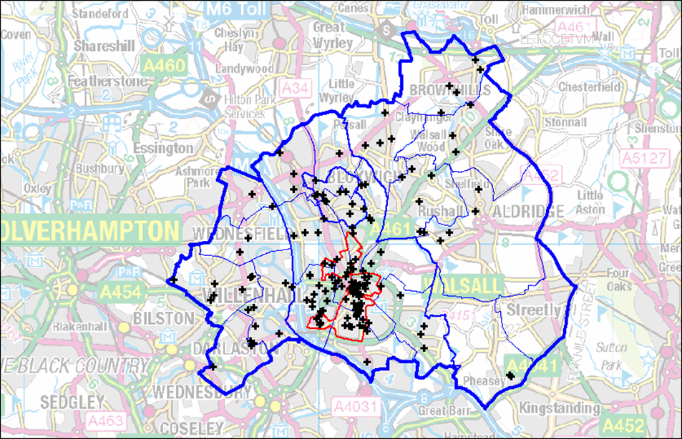

Count of Person Or Vehicle
Person Or Vehicle | Total
Person | 211
Person and Vehicle | 30
Vehicle | 8
(blank)
Grand Total | 249
Outcome Description | Total
Arrested - Consequence of Stop and Search | 23
Arrested - Unrelated Offence including Warrant / PNC | 7
Cannabis Warning | 10
Community Resolution | 3
Conditional Bail | 1
Fixed Penalty | 6
NFA | 196
Street Summon | 3
Ethnic Desc | Total
ASIAN OR ASIAN BRITISH - PAKISTANI | 16
ASIAN OR ASIAN BRITISH - INDIAN | 21
ASIAN OR ASIAN BRITISH - OTHER | 3
BLACK OR BLACK BRITISH - AFRICAN | 6
BLACK OR BLACK BRITISH - CARIBBEAN | 11
BLACK OR BLACK BRITISH - OTHER | 5
MIXED - OTHER | 2
MIXED - WHITE AND ASIAN | 4
MIXED - WHITE AND BLACK AFRICAN | 1
MIXED - WHITE AND BLACK CARIBBEAN | 4
NOT APPLICABLE | 8
NOT STATED - NOT STATED | 2
WHITE - OTHER | 17
WHITE - BRITISH | 149
(blank)
Grand Total | 249
Knife Crime

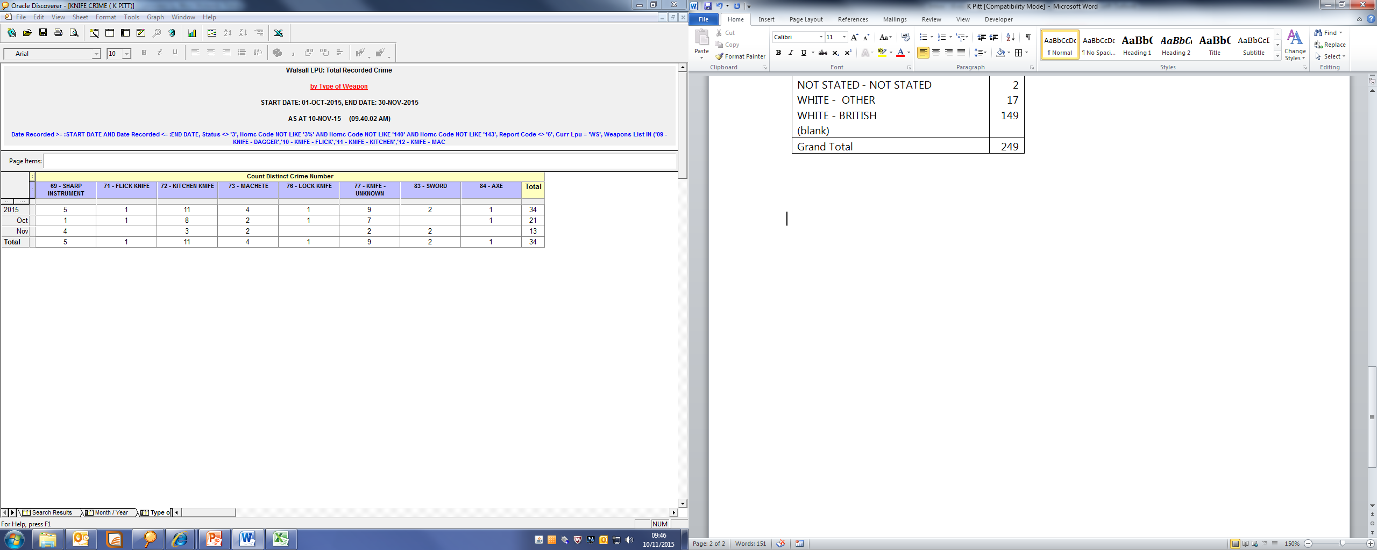
Hate Crime as of 10th November.
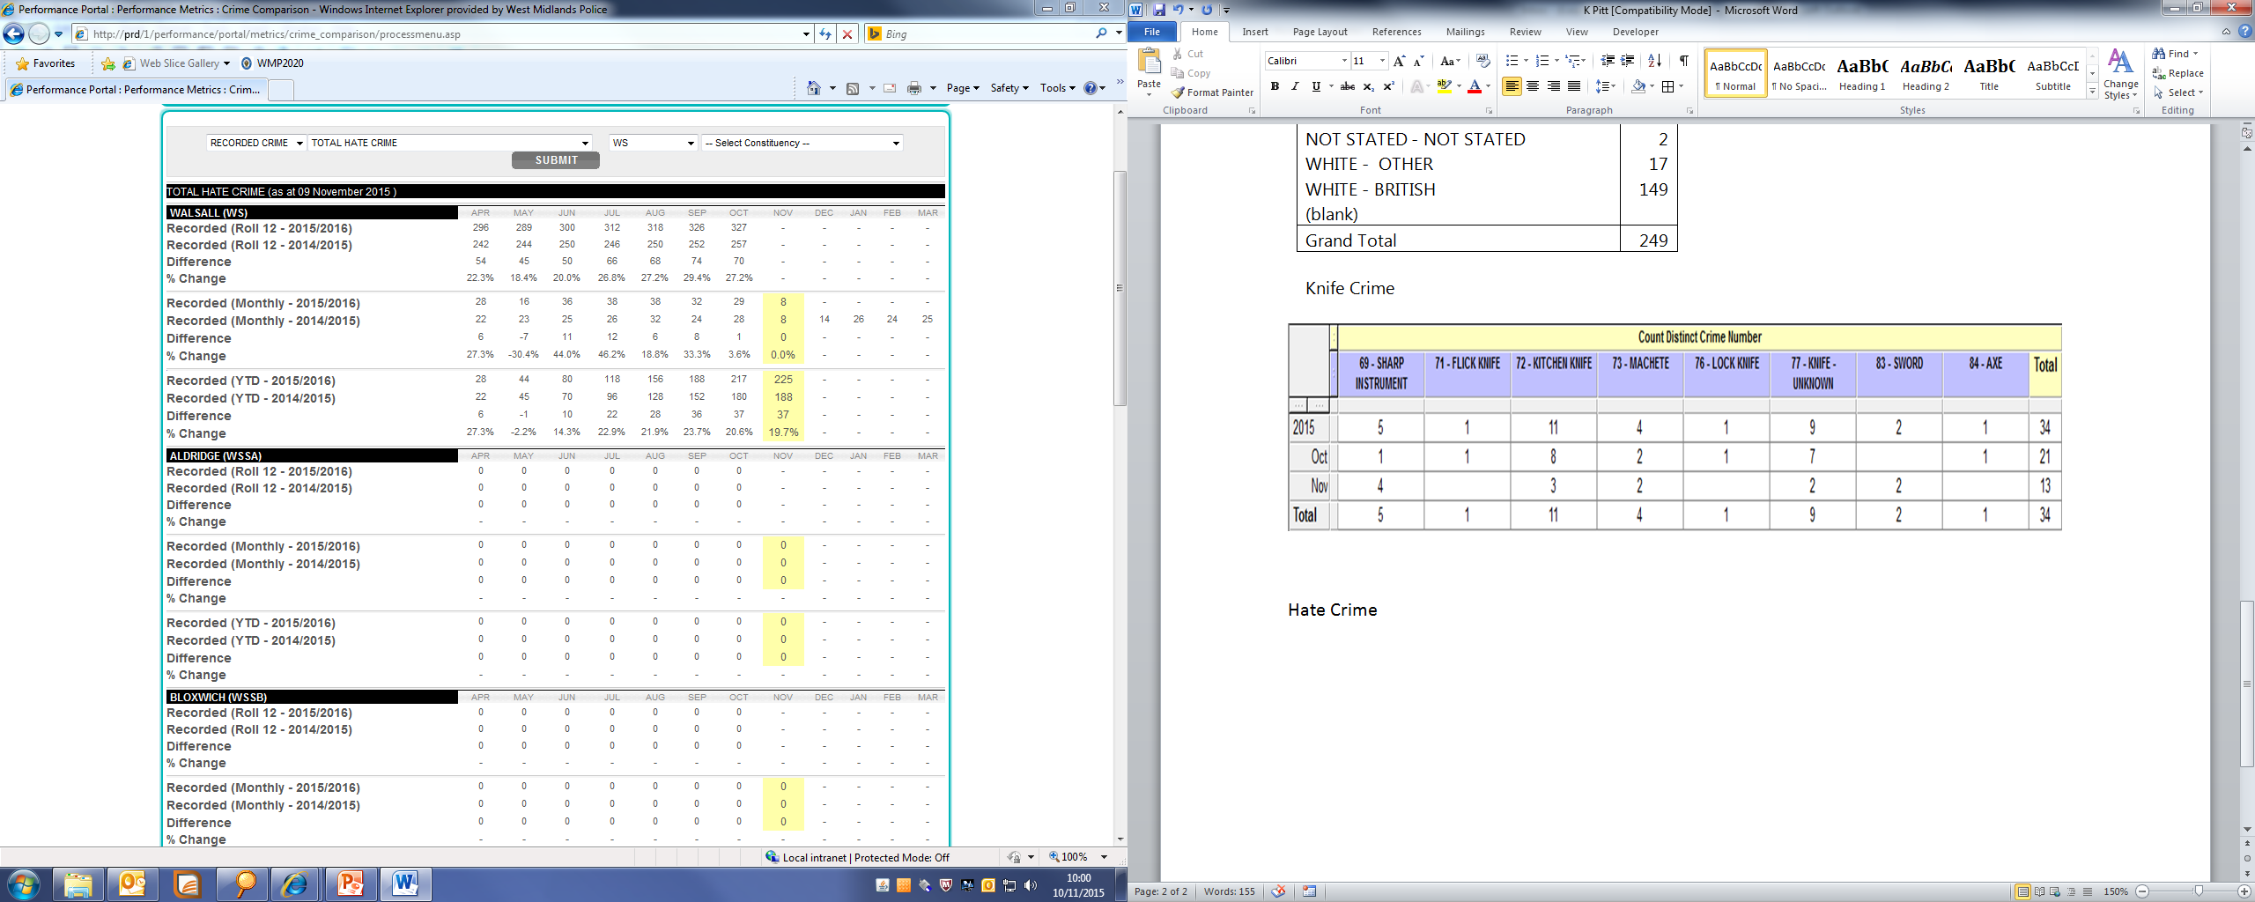

The following stop and search records were scrutinised.

SSWS-LESJ-27527.
No comment other than why no further action was taken.

SSWS-0QLI-27399
The grounds given for the stop and search – acting suspiciously – required elaboration.

SSWS-HGPP-27354
As above elaboration required.

SSWS-B0CK-27264
Good police action in responding to male seen trying car doors.

Hate Crime – Sergeant Gary Iliff.
GI explained that most reported hate crime is racially or religiously motivated and that levels seem to go up and down in response to world events. Disability crime in particular is under reported.

To assist hate crime reporting, third party reporting centres are available across Walsall. They are:

WS | 1 | Beechdale Community Housing | Chilton House, Stephenson Avenue, Walsall WS2 7EU
WS | 2 | Caldmore / Accord Housing ASB Unit | 18 Caldmore Green, Caldmore, Walsall. WS1 3RL
WS | 3 | Golden Lion bar | Birchills Street, Walsall. WS2 8NG
WS | 4 | Midlands Polish Community Centre | Joseph Leckie Academy, Walstead Road, Walsall. WS5 4PG
WS | 5 | My Place | 60 Walstead Road West, Walsall. WS5 4PE
WS | 6 | Old Hall people's Partnership, Wing Close Centre | Wing Close, Bentley, Walsall. WS2 0BD
WS | 7 | The Hub, Walsall Mencap | Lichfield Street, Walsall. WS1 1TU
WS | 8 | Walsall College | Littleton Street West, Walsall, WS2 8ES
WS | 9 | Walsall Deaf Centre | 59A Lichfield Street, Walsall, WS4 2BX
WS | 10 | Walsall Housing Group ASB unit | 100 Hatherton Street, Walsall. WS1 1AB

GI also explained that he is organising some women only events to highlight domestic abuse and other issues that affect the family. He asked for ideas on how to pitch the event.

ACTION – KP to ask group members for ideas.

Any Other Business

ACTION – if possible put modern day slavery on the next meeting agenda.

GM explained that he volunteered for the Citizen’s Advice Bureau as a research volunteer and about CAB’s campaigns and petitions, e.g. around consumer law.

BE asked about WMP’s funding. The exact amount allocated to WMP by the Home Office is not yet known.

Date of Next Meeting.

Thursday 21 January, 6pm at Walsall Police Station.

