Walsall Strategic Community Reference Group
Minutes of meeting held on Thursday 24 November 2016 at Bloxwich Police Station.
In attendance:
Nirmal Singh (NS) SCRG Chair/Sikh Forum
Elizabeth Kardynal (EK) EWA CIC
Julie Finch (JF) CUSP/ NHW Pleck
Rose Burley (RB) Councillor Bentley and Darlaston North
Noreen Shaw (NSh) Walsall Over 50’s Forum
Vasant Mistry (VM) Walsall Hindu Forum
Ryan Steane (RS) Policing Student/Brownhills
Sandeep Singh Sohal (SS) Walsall Sikh Forum
Ken Ferguson (KF) Brownhills Councillor
Mr R K Mehmi (RM) SGRT Darlaston
Mahmood M Sacha (MS) Muslim Welfare Society/UMO
Imran M Sacha (IS) Muslim Welfare Society
Jo Clews (JC) Commander, Walsall Police
Kevin Pitt (KP) Walsall Police

Apologies:
Alison Davies
Peter Griffin
Teresa Brown

Minutes of Last Meeting and Matters Arising.
The minutes of the last meeting were read and accepted.

KF questioned that if 90% of neighbourhood officers were remaining in post, why had Brownhills seen a 50% change? JC replied that Walsall currently has 52 neighbourhood police officers in post out of a possible 56 (4 vacancies). Some staff have been re-aligned to meet the greatest need and to balance staff to ensure no gaps in knowledge, etc. Movement has been kept to the minimum.

KF asked if Chief Superintendent Clews would be moving, she replied not in the foreseeable future.

The Senior Leadership Team at Walsall Neighbourhood Policing Unit consists of local commander Chief Superintendent Clews supported by Superintendent Sue Parker and newly-promoted Chief Inspector Jason Anderson. We may get a second Chief Inspector.

RB asked if the police could be represented at local meetings. JC replied yes if staffing allows. Representatives were asked to send meeting details to KP who would ask sector inspectors to attend if possible.

Following an enquiry from JF the group discussed prostitution and CSE.

A discussion then took place about hate crime; under-reporting and how reporting could be encouraged.

Police Update.
JC updated the group on the move to Bloxwich and the Walsall Police Station Closure event.

Big changes are happening within the police with response teams moving to central control. The Neighbourhood Policing Unit will retain control of Neighbourhood Policing Teams, Neighbourhood Task Force (consisting of 1 Inspector, 2 Sergeants and 14 PC’s), an expanded Offender Management Team and for now an investigation team.

New technology includes new crime recording and investigation systems, some investigation will take place over the phone or by appointment, in future it will be possible to report some less serious crimes over the internet.

New Ways of Working include the new Bloxwich Police Station, more meetings, etc. being held via Skype and changes to police HQ, Lloyd House, which has had it’s capacity doubled. Body worn video is being rolled out. Most officers will shortly receive mobile devices (smartphones) utilising bespoke apps.

Crime update: though the force has seen a rise in crime of 10.8%, Walsall has seen an increase of just 0.8% making Walsall LPU/NPU the best performing in the force. Violence With Injury has fallen by 2% over last year (much of it domestic abuse).

Partners are now working more closely together, e.g. supporting troubled families and vulnerable individuals, addressing problems earlier, e.g. ACE (Adverse Childhood Experiences) Factors.

ACTION – KP to circulate ACE factor information.

Update – Completed 1/12/16.

KP gave the group an overview of WMP’s new community messaging system, WMNow, and urged them to register to receive messages by visiting www.wmnow.co.uk.

Hate Crime Update
KP gave the group the following information and a discussion took place.

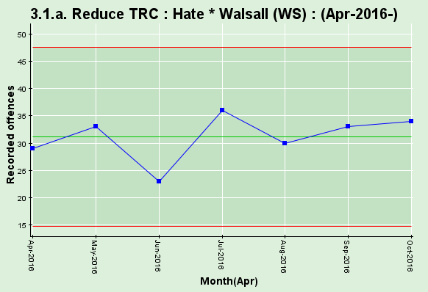

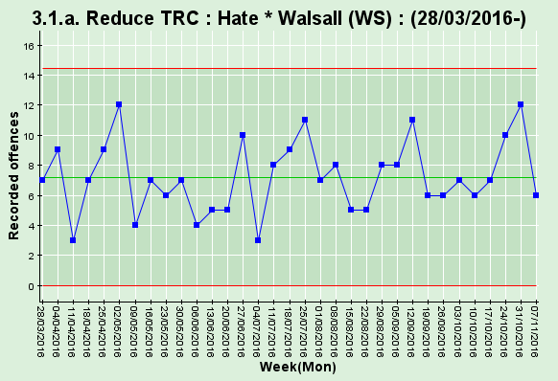

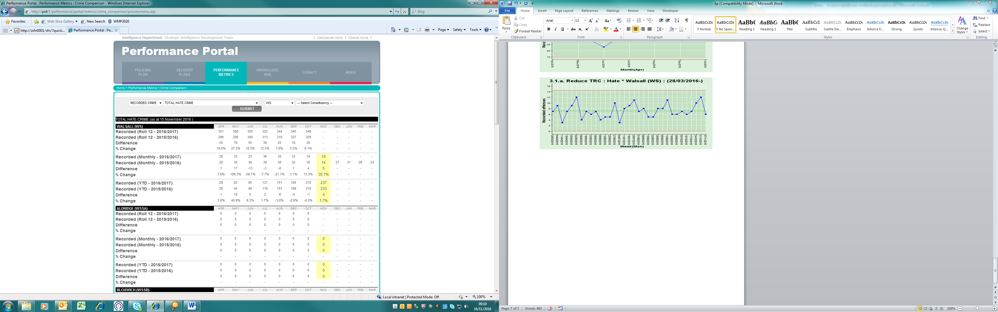

Stop and Search Scrutiny Panel
The following stop and search records were viewed and scrutinised:

SSWS-VAJL-44711
SSWS-IBKB-44514
SSWS-GATB-44474
SSWS-4FSW-43789

The group raised a query regarding the final record, which showed an out of custody caution, they were happy with the grounds but wondered why this was done when no property was recovered, what was the caution for?

ACTION – KP to contact Inspector Dave Whordley to clarify.

Update 12/1/17: Insp Dave Whordley reports that the outcome had been incorrectly recorded, it has now been amended to ‘no further action’.

Any Other Business

EK asked KP to circulate a link to the ‘Better Than That’ campaign.
(Update – completed 25/11/16)

NS raised concerns about people riding bicycles without lights. After a discussion it was decided this was best addressed within the community and through education.

SS enquired how to report drug dealing in Caldmore. Advised to ring 101.

NSh enquired why a newly-recruited PC would want to come to work in Walsall. The answer – partnership working!

JF enquired whether WMP conduct on the spot drug testing for drivers, answer yes.

EK enquired how many vacancies were being carried by Walsall NPU. The answer was not known exactly but there are very few.

ACTION – KP to invite Prevent Co-ordinator Bob Spencer to the next meeting.

Update – Mr Spencer contacted and accepted invitation 25 November.

Close and Date of Next Meeting
The next meeting will be held at 6pm on Thursday 19 January at Bloxwich Police Station.

