Walsall Strategic Community Reference Group
Minutes of meeting held on Thursday 19 January 2017 at Bloxwich Police Station.
In attendance:
Nirmal Singh (NS) SCRG Chair/Sikh Forum
Elizabeth Kardynal (EK) EWA CIC
Matthew Danks (MD) Walsall College
Andy Thompson (AT) Street Teams
Helen Matthews (HM) Street Teams
Alison Davies (AD) Mencap
Peter Griffin (PG) Mencap and Walsall College/WACC
Teresa Brown (TB) Disability Forum
Noreen Shaw (NSh) Walsall Over 50’s Forum
Vasant Mistry (VM) Walsall Hindu Forum
Sandeep Singh Sohal (SS) Walsall Sikh Forum
Ken Ferguson (KF) Brownhills Councillor
Mr R K Mehmi (RM) SGRT Darlaston
R Mehmi (RMh) SGRT Darlaston
Aisha Khan (AK) Aaina Community Hub
Jonathan Booker (JB) Walsall College
Mahmood M Sacha (MS) Muslim Welfare Society/UMO
Imran M Sacha (IS) Muslim Welfare Society
Bob Spencer (BS) Walsall MBC – Prevent Co-ordinator
Kris Starynskyj (KS) Walsall Police
Jo Clews (JC) Commander, Walsall Police
Kevin Pitt (KP) Walsall Police

Apologies:
Rose Burley
Julie Finch
Nasar Iqbal
Debo Adesina
Sophie Worthington

Minutes of Last Meeting and Matters Arising.
The minutes of the last meeting were read and accepted.

Counter-Terrorism PREVENT update from Mr Bob Spencer, Walsall MBC
BS explained that Prevent is part of the government’s counter-terrorism strategy, CONTEST and aims to prevent people becoming involved in terrorism or extremism. It was set up under the Counter Terrorism Act 2015 which places a duty on all relevant authorities being drawn into terrorism. It is an Ofsted priority so schools are involved.

BS offered WRAP (Workshop to Raise Awareness of Prevent) training to group members.

ACTION – KP to circulate offer of WRAP training to group members.

Thousands of people nationally have gone through ‘Channel panels’ which is a legal obligation which raises awareness and is an early opportunity to intervene with people in danger of being drawn to terrorism. It has a 90% success rate. Recently 4000 professionals from education, NHS, etc. have been trained. They do not spy but recognise vulnerability. Those identified are not criminalised but helped. Walsall has more arrests than the rest of the West Midlands, mostly people with a desire to travel. Some have travelled, 800 people from the UK are reportedly in Syria. Danger from some who may come back plus frustrated people unable to travel.

NS asked about practise drills. It was explained by BS and JC that various counter-terrorism and civil defence exercises take place.

RM enquired if people coming into the country are filtered or checked. BS replied this is not part of Prevent but the responsibility of police and security forces working with the Border Force.

The current threat level for international terrorism in the UK is SEVERE (an attack is highly likely) and has been for some time.

AK enquired if right-wing activity affects Walsall. BS replied he ws not aware of any substantial activity in Walsall. A far-right group called National Action is now illegal. The Extreme Right Wing (XRW) is active locally however no rise following the Brexit vote and Jo Cox murder has been detected. The EDL have shifted the focus of their activity to Birmingham. We need to challenge and prevent any activity.

AK enquired as to the level of terrorist activity now. BS replied that there is still a particular lack of awareness among ‘middle class’ families whose children are vulnerable to radicalisation. Prevent activity is focusing more around young people and their grievances, e.g. activity by Street Teams and in schools on British values (including the XRW), new resources will be available to schools by the end of February.

AT explained how Street Teams are going into schools to consult with young people.

MS invited BS and Street Teams to work with him in schools. There has been an increase in hate crime but it is not being reported. Asian women particularly wearing traditional dress are being cautious.

BS invited mosques, schools etc. to contact him and to work with him. Look out for XRW stickers and graffiti.

Police Update.

JC gave an update on the WMP2020 programme. Some teething problems have been encountered but worked out. Neighbourhood policing teams are going to fewer incidents, allowing them to concentrate more time in communities solving problems. New mobility devices with bespoke apps are enabling officers and PCSO’s to spend more time out of police stations. WMNow is up and running and a new internet site is due soon. The police are working with partners to identify causes of crime, e.g. vulnerability, ACE factors, etc. We are going back to review cases more often, e.g. checking back on a young girl who has been abused, to make sure she was still safe.

KS gave an example of how the new mobility devices were used to quickly assess some possible XRW graffiti, by taking a photo and emailing to Counter Terrorism Unit the officer on the street was able to get risk assessed very quickly without coming back into the office. (There was no concern in this case).

The West Midlands as a whole has experienced a 11% rise in total recorded crime over the last year, however in Walsall the rise has been just 0.8%, the lowest of any area. Public place violence with injury was up 3.5% across the whole force area, however was down by 3.5% in Walsall, likely because police have concentrated on educating the student population, e.g. Safer Travel (public transport).

Police are conscious of the under-reporting of hate crime and are building relationships with partners and the community to address this.

JC made a commitment to work with the community to reduce hate crime and asked members of the group if they would be interested in taking part, e.g. a ‘task and finish’ group to address the issues.

The group discussed hate crime in general.

Stop and Search Scrutiny Panel

KP presented the following information to the group.

Stop and Search December 2016.

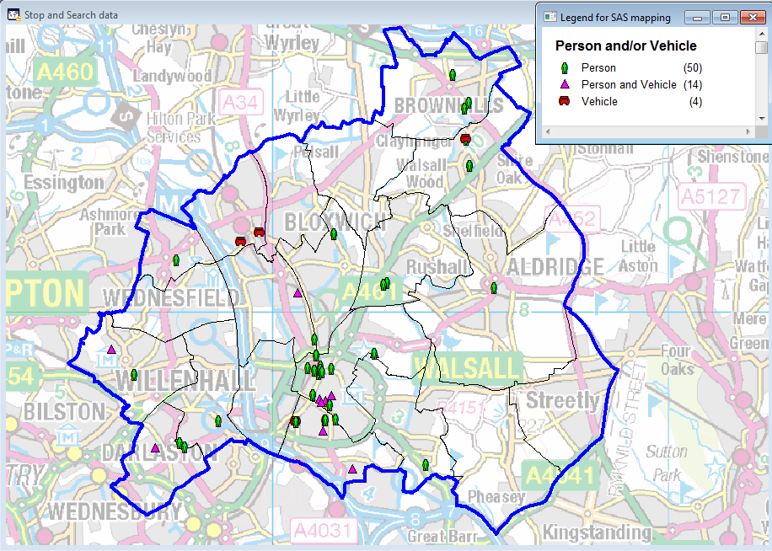

Ethnic Desc | Total
ASIAN OR ASIAN BRITISH - PAKISTANI | 12
ASIAN OR ASIAN BRITISH - INDIAN | 4
ASIAN OR ASIAN BRITISH - OTHER | 3
BLACK OR BLACK BRITISH - CARIBBEAN | 3
BLACK OR BLACK BRITISH - OTHER | 1
MIXED - WHITE AND BLACK CARIBBEAN | 5
NOT APPLICABLE | 4
NOT STATED - NOT STATED | 2
WHITE - OTHER | 2
WHITE - BRITISH | 32
(blank)
Grand Total | 68

Outcome Description | Total
Arrested - Consequence of Stop and Search | 10
Cannabis Warning | 4
Community Resolution | 1
NFA | 52
Street Bail | 1
(blank)
Grand Total | 68

YTD Disproportionality
2015-16 as at 9-Jan-2016
 | White |  | Asian |  |  | Black
 | S & S | Pop | S & S | Pop | Disp Rate | S & S | Pop | Disp Rate | Total
BE | 823 | 154,666 | 913 | 142,954 | 1.2 | 205 | 22,797 | 1.7 | 2,107
BN | 745 | 155,673 | 216 | 16,498 | 2.7 | 135 | 11,852 | 2.4 | 1,179
BS | 629 | 234,013 | 99 | 33,006 | 1.1 | 141 | 16,627 | 3.2 | 993
BW | 605 | 77,279 | 625 | 93,180 | 0.9 | 679 | 45,083 | 1.9 | 2,117
CV | 773 | 234,029 | 156 | 51,598 | 0.9 | 150 | 17,764 | 2.6 | 1,173
DY | 674 | 281,610 | 95 | 18,941 | 2.1 | 61 | 4,671 | 5.5 | 891
SH | 594 | 184,247 | 149 | 13,561 | 3.4 | 58 | 3,239 | 5.6 | 871
SW | 496 | 215,469 | 247 | 59,260 | 1.8 | 156 | 18,357 | 3.7 | 993
WS | 1,187 | 212,479 | 360 | 41,026 | 1.6 | 140 | 6,369 | 3.9 | 1,828
WV | 669 | 169,672 | 151 | 44,956 | 0.9 | 153 | 17,309 | 2.2 | 1,129
Total | 7,195 | 1,919,137 | 3,011 | 514,980 | 1.6 | 1,878 | 164,068 | 3.1 | 13,281

2016-17 as at 9-Jan-2017
 | White |  | Asian |  |  | Black
 | S & S | Pop | S & S | Pop | Disp Rate | S & S | Pop | Disp Rate | Total
BE | 1,072 | 310,339 | 809 | 159,452 | 1.5 | 272 | 34,649 | 2.3 | 2,408
BW | 976 | 311,292 | 780 | 126,186 | 2.0 | 986 | 61,710 | 5.1 | 3,049
CV | 565 | 234,029 | 153 | 51,598 | 1.2 | 86 | 17,764 | 2.0 | 886
DY | 443 | 281,610 | 78 | 18,941 | 2.6 | 44 | 4,671 | 6.0 | 627
SH | 539 | 184,247 | 165 | 13,561 | 4.2 | 82 | 3,239 | 8.7 | 879
SW | 418 | 215,469 | 198 | 59,260 | 1.7 | 110 | 18,357 | 3.1 | 807
WS | 562 | 212,479 | 145 | 41,026 | 1.3 | 87 | 6,369 | 5.2 | 893
WV | 552 | 169,672 | 149 | 44,956 | 1.0 | 180 | 17,309 | 3.2 | 989
Total | 5,131 | 1,919,137 | 2,477 | 514,980 | 1.8 | 1,847 | 164,068 | 4.2 | 10,542

Previous month Disproportionality

01/12/2015 - 08/01/2016
 | White |  | Asian |  |  | Black
 | S & S | Pop | S & S | Pop | Disp Rate | S & S | Pop | Disp Rate | Total
BE | 145 | 154,666 | 121 | 142,954 | 0.9 | 30 | 22,797 | 1.4 | 318
BN | 77 | 155,673 | 30 | 16,498 | 3.7 | 18 | 11,852 | 3.1 | 135
BS | 89 | 234,013 | 15 | 33,006 | 1.2 | 14 | 16,627 | 2.2 | 134
BW | 124 | 77,279 | 121 | 93,180 | 0.8 | 142 | 45,083 | 2.0 | 424
CV | 154 | 234,029 | 36 | 51,598 | 1.1 | 42 | 17,764 | 3.6 | 248
DY | 85 | 281,610 | 15 | 18,941 | 2.6 | 10 | 4,671 | 7.1 | 119
SH | 74 | 184,247 | 18 | 13,561 | 3.3 | 3 | 3,239 | 2.3 | 103
SW | 73 | 215,469 | 30 | 59,260 | 1.5 | 15 | 18,357 | 2.4 | 132
WS | 158 | 212,479 | 36 | 41,026 | 1.2 | 15 | 6,369 | 3.2 | 231
WV | 86 | 169,672 | 23 | 44,956 | 1.0 | 26 | 17,309 | 3.0 | 153
Total | 1,065 | 1,919,137 | 445 | 514,980 | 1.6 | 315 | 164,068 | 3.5 | 1,997

01/12/2016 - 08/01/2017
 | White |  | Asian |  |  | Black
 | S & S | Pop | S & S | Pop | Disp Rate | S & S | Pop | Disp Rate | Total
BE | 78 | 310,339 | 92 | 159,452 | 2.3 | 25 | 34,649 | 2.9 | 215
BW | 112 | 311,292 | 94 | 126,186 | 2.1 | 77 | 61,710 | 3.5 | 317
CV | 70 | 234,029 | 24 | 51,598 | 1.6 | 15 | 17,764 | 2.8 | 125
DY | 26 | 281,610 | 9 | 18,941 | 5.1 | 3 | 4,671 | 7.0 | 45
SH | 49 | 184,247 | 11 | 13,561 | 3.1 | 9 | 3,239 | 10.4 | 78
SW | 48 | 215,469 | 21 | 59,260 | 1.6 | 7 | 18,357 | 1.7 | 85
WS | 48 | 212,479 | 26 | 41,026 | 2.8 | 6 | 6,369 | 4.2 | 92
WV | 67 | 169,672 | 12 | 44,956 | 0.7 | 23 | 17,309 | 3.4 | 118
Total | 498 | 1,919,137 | 289 | 514,980 | 2.2 | 165 | 164,068 | 3.9 | 1,075

YTD Positive Outcome rates by ethnicity

Positive Outcome rate YTD 9-Jan-2016
LPU | 01 WHITE | 02 BLACK | 03 ASIAN | Grand Total
BE | 26.5% | 27.3% | 26.3% | 26.5%
BN | 27.8% | 31.1% | 31.5% | 28.2%
BS | 28.0% | 32.6% | 30.3% | 29.2%
BW | 23.5% | 23.7% | 22.6% | 23.5%
CV | 20.1% | 26.7% | 23.7% | 22.0%
DY | 24.8% | 24.6% | 42.1% | 26.2%
SH | 23.4% | 36.2% | 24.2% | 24.0%
SW | 23.2% | 37.2% | 23.5% | 26.7%
WS | 19.9% | 31.4% | 23.3% | 21.8%
WV | 27.8% | 29.4% | 30.5% | 28.8%
Grand Total | 24.2% | 28.1% | 25.9% | 25.4%

Positive Outcome rate YTD 9-Jan-2017
LPU | 01 WHITE | 02 BLACK | 03 ASIAN | Grand Total
BE | 30.7% | 32.0% | 28.4% | 29.5%
BW | 25.8% | 21.4% | 28.2% | 25.1%
CV | 51.5% | 23.3% | 35.3% | 27.8%
DY | 30.2% | 34.1% | 24.4% | 29.7%
SH | 25.4% | 35.4% | 26.7% | 27.0%
SW | 29.9% | 33.6% | 30.3% | 31.2%
WS | 28.3% | 27.6% | 20.7% | 26.8%
WV | 29.0% | 37.2% | 35.6% | 32.1%
Grand Total | 28.0% | 26.5% | 28.7% | 28.0%

Previous month Positive Outcome rates by ethnicity

Positive Outcome rate 01/12/2015 - 8/1/2016
LPU | 01 WHITE | 02 BLACK | 03 ASIAN | Grand Total
BE | 19.3% | 33.3% | 21.5% | 22.3%
BN | 27.3% | 27.8% | 26.7% | 27.4%
BS | 40.4% | 14.3% | 33.3% | 38.8%
BW | 22.6% | 24.6% | 20.7% | 22.9%
CV | 16.9% | 16.7% | 27.8% | 20.2%
DY | 24.7% | 50.0% | 26.7% | 27.7%
SH | 33.8% | 0.0% | 22.2% | 31.1%
SW | 21.9% | 46.7% | 33.3% | 29.5%
WS | 17.7% | 33.3% | 22.2% | 19.5%
WV | 29.1% | 23.1% | 43.5% | 29.4%
Grand Total | 23.8% | 26.0% | 24.7% | 25.1%

Positive Outcome rate 01/12/2016 - 8/1/2017
LPU | 01 WHITE | 02 BLACK | 03 ASIAN | Grand Total
BE | 30.8% | 40.0% | 37.0% | 33.5%
BW | 17.0% | 15.6% | 22.3% | 19.9%
CV | 30.0% | 53.3% | 29.2% | 33.6%
DY | 19.2% | 33.3% | 0.0% | 17.8%
SH | 36.7% | 11.1% | 36.4% | 34.6%
SW | 27.1% | 57.1% | 52.4% | 37.6%
WS | 29.2% | 50.0% | 23.1% | 27.2%
WV | 26.9% | 39.1% | 33.3% | 32.2%
Grand Total | 26.5% | 29.1% | 30.1% | 28.6%

The following stop and search records were scrutinised:

SSWS-JJB4-46388
SSWS-IG89-46245
SSWS-EDEA-46024
SSWS-IZUD-45955
SSWS-SOF7-45945

No concerns were raised.

Any Other Business

KF asked how the police now deal with off-road motorcycles. JC replied that police would have to get in support, assess the risk and how to prevent, e.g. barriers, awareness in schools, etc.

KP reminded members to register on the WMNow messaging system, www.wmnow.co.uk.

Date of Next Meeting.
Thursday 30 March, 6pm at Bloxwich Police Station.

