Service Specification for a Pre-Arrest Drug Diversion Scheme
Statement of Requirement

1. Introduction
1.1 The West Midlands Police and Crime Commissioner wants to commission a Pre-Arrest Drug Diversion scheme across the whole force area. This programme would form part of a wider diversion, prevention and intervention strategy, managed by West Midlands Police (WMP), which is aimed at reducing offending and reoffending.
2. Context
2.1 This programme arises from one of the Police and Crime Commissioner’s eight Drug Policy Recommendations (2018):
Recommendation 1: West Midlands Police and partners to establish a formal diversion scheme that includes tackling problematic drug use primarily through routes other than the criminal justice system, in order to reduce reoffending, protect public health and improve community safety. This will build on the success of the West Midlands Police Turning Point pilot.
2.2 The majority of offenders charged to court for low level drug offences, will receive a fine or custodial sentence. This punishes the individual, but is unlikely to change offending behaviour. It is also well-evidenced that short prison sentences increase the totality of an individual’s offending across their criminal lifespan. WMP strategy is to work with our partners and divert emerging offenders from court into the most appropriate intervention to reduce reoffending.
2.3 Despite this, over the past 6 years, use of out of court disposals by WMP has reduced. Since 2014/15, the proportion of crime outcomes (excluding violence and sexual offences) that were informal out of court disposals, has reduced from 20% to 11%. Similarly, formal out of court disposals have reduced from 14% to 10%.
2.4 This scheme aims to contribute to a culture change in policing. It builds on successful pilots and will increase understanding of ‘what works’ to reduce reoffending across areas of the highest risk and harm.

COVID-19
2.6 Circumstances at the moment place a greater need to utilise alternative criminal justice pathways. The current backlog in the court system means that any new cases will be significantly delayed and would further contribute to this increasing number. WMP are urgently looking to increase the number of out of court disposals and diversion opportunities that are available, in order to try and reduce the burden. Having this programme in place, would help to reduce any further strain that would normally be put on the criminal justice system with these type of offences.
2.7 Ultimately, as demand rises and capacity is reduced for WMP and the wider criminal justice system, evidence-based diversion options will be vital to achieving better outcomes and freeing up police resources to better protect the public.

3. The Grant
3.1 The funding for this service will be for 12 months, with an option to extend. That decision will be made by the Police and Crime Commissioner in consultation with WMP.
3.2 The budgeted value for this service is £60,000 per annum and the project will be grant funded.
3.3 We expect this service to go live as soon as possible, following the completion of the application process.
3.4 It is expected, based on WMP data, that this scheme would be required for approximately 1500 individuals over a 12 month period.
3.5 Monitoring and day-to-day management of this service will sit with Nicola Lloyd (Neighbourhood Justice Manager for WMP) and her team.

4. The Service
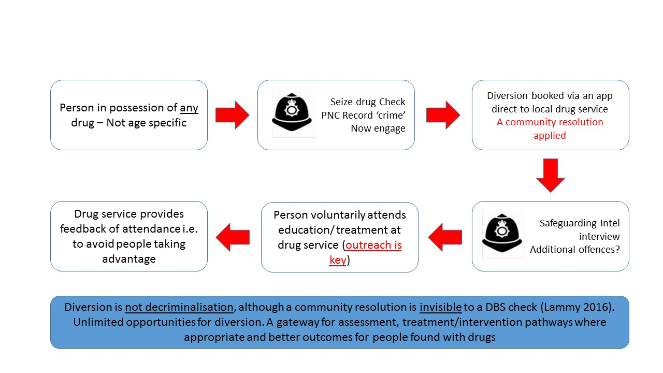
4.1 Process Flowchart:

4.2 The above flowchart sets out how the scheme would work.
4.3 This scheme is available for both adults and juveniles.
4.4 This diversion is for ‘simple’ possession of controlled drugs only. Any ‘Possession with Intent to Supply’ offences would be excluded.
4.5 This process involves applying a community resolution. This is a non-statutory, out of court disposal (OOCD) for officers to utilise. Community resolutions do not lead to a criminal record.
4.6 It is a voluntary referral scheme that functions within the constraints of current nationally accepted legal frameworks. For more info on community resolutions see: http://library.college.police.uk/docs/appref/Community-Resolutions-Incorporating-RJ-Final-Aug-2012-2.pdf.
4.7 It is not a deferred prosecution model – the individual does not need to abide by the conditions that have been set by the police, in order to avoid prosecution for the offence.

How it would work in practice:
4.8 A WMP officer would search an individual on the suspicion that they are in possession of a controlled substance or on suspicion that they are carrying out a separate offence.
4.9 The starting point for referral is that all persons found in ‘possession of a controlled drug’ contrary to section 5 of the Misuse of Drugs Act 1971 would be eligible. Should a controlled substance be found, the officer would then use their discretion to determine what would be the best approach for this individual:
- Firstly, the officer must ascertain confirmation of the individual’s identity.
- The officer will then be able to check online systems that shows an individual’s personal record. Based on compliance with previous diversion schemes, the quantity of drugs they possess* and previous offending history, the officer will decide if a community resolution would be appropriate.
- *WMP officers must use discretion to determine if the quantity of drugs qualifies as ‘for personal use’, or leads to ‘suspicion of supply’.*
- This diversion is for ‘simple’ possession of controlled drugs offences only.
- Any ‘Possession with Intent to Supply’ offences are excluded from this scheme.
- It will be made clear that there is an incentive to attend the diversionary sessions. As long as the conditions of the diversion scheme are adhered to, the individual would then be eligible for another referral, not prosecution, should they be found in possession of a controlled substance on a different occasion.
- Persons can be referred to diversionary schemes numerous times, as long as they have abided by the conditions of each referral. If, however, a person was referred and they did not complete the required number of sessions, then they would not be eligible for further diversions in future. The threat therefore hangs over them, that if they are found in possession of a controlled substance on another occasion, and haven’t met the conditions of a previous diversion programme, they will be dealt with more severely.
4.10 Should it deemed that the person can be diverted, the officer will be able use an online booking system that will be accessible via police phones and/or systems
4.11 This means booking of appointments can be completed on the street whilst with the offender.
4.12 The individual will then be free to leave and will have the option of whether they want to attend the session that has been booked for them.
5. The Provider:
Programmes
5.1 Outreach from the provider is essential, in order to contact individuals that have been referred. This outreach must be prompt and engaging, in order to try and encourage attendance.
5.2 The service provider must have a number of tailored diversion routes available, that will address an individual’s use of drugs.
5.3 Specialist support should be provided with the aim of reducing harm and ultimately preventing the cycle of reoffending and long term demand upon the police and judicial services.
5.4 Sessions can include:
- Drug / alcohol awareness.
- Consequences of possession.
- Cost of drug use / cost to society etc.
- Offending behaviour.
- Peer mentor shared experiences.
- Post-DEP support.
- 1-2-1 closure meeting.
5.5 The service provider will be expected to demonstrate their ability to tailor their service in such a way, as to maximise the chances of sustained engagement with people of all ages.
5.6 The service provider will need to have an understanding that the client group may be from diverse communities; may have educational needs, chaotic lifestyles, and language barriers and may be from hard to reach or closed communities.
Organisational Capacity
5.7 The provider must be able to demonstrate the capacity to take referrals from across the whole WMP force area. (Birmingham, Coventry, Wolverhampton, Walsall, Sandwell, Solihull and Dudley.)
5.8 The service provider must have sufficient internal resilience to manage service provision throughout major holiday periods as and when required and an out of business hours capability.
5.9 Regular and accurate communication between the service provider and WMP is of paramount importance.
5.10 The service provider should regularly audit skills and training, to ensure the programmes are up to standard and refresh levels of training as required.
5.11 The provider must be willing to engage with WMP, in order to ensure that all relevant officers are aware of this programme. Training should be provided if necessary.
Online Booking System
5.12 It will be looked on favourably, if a provider has an online booking system that officers can use to book individuals onto relevant programmes. This system must be easily accessible and simple to use.
5.13 It is expected that the service provider will be flexible and responsive in regards the ways in which referrals are received, processed and managed.
5.14 The provider must be able to regularly provide detailed and up to date records – showing accurate attendance/engagement rates for each individual. The online system must be regularly updated, so that WMP officers can check to see if an individual has complied with previous programmes.

6. Covid – 19
6.1 It is expected that the provider will have capacity to deliver this service, despite any restrictions that may be in place due to Covid-19.
6.2 Provisions should be put in place to provide sessions remotely, where necessary.
7. Partnership Engagement
7.1 If an individual is identified as having more complex issues, such as an underlying addiction, the provider must be able to refer this person onto an adequate treatment / support pathway.
7.2 The provider should be able to demonstrate links with partner organisations across the region, in order to signpost individuals into further support that is deemed necessary e.g Housing services, Citizens Advice Bureau, mental health support etc.
7.3 It is expected that the provider should be able to work with local Youth Offending Services and link in with the Youth Justice System, where necessary.
7.4 There are various drug service providers within each local authority area. The provider of this service must be able to engage with these services and exchange information on an individual, if needed.
7.5 In addition, where it is felt that an individual may be better suited to a more specific treatment programme from their local drug service provider, then this referral should be made.
7.6 Prospective service providers will need to clearly describe the methods they will use to:
- Identify which other statutory / social / community organisations / programmes that individuals have or are already engaging with; and
- how they will maintain communication with those organisations throughout the programme (to avoid duplication and ensure a cohesive and joined up approach to supporting the client(s).
- How they will conduct a needs assessment to identify and signpost any necessary transformational opportunities and services to other social / community organisations, following the conclusion of an intervention.
8. Information Management
8.1 It will be the provider’s responsibility to provide a case management system and to ensure that it is compatible with West Midlands Police existing ICT infrastructure before the commencement of the service and allow sufficient funds for any upgrades that are required to ensure compatibility. The OPCC will discuss requirements once the commissioning process is complete and the provider has been appointed.
8.2 The service provider must be able to collate and record accurate and timely management information that can be used to update stakeholders regarding strategic and operational performance.
8.3 This database should include the number of sessions attended per person, an up to date comprehensive record of case progression and a record of case management and outcomes.
8.4 It is vital that the service provider provides regular progress reports to ensure that regular case updates can be disseminated to the originating referrer.
8.5 The service provider must therefore demonstrate their ability to store and manage large amounts of sensitive information in accordance with GDPR requirements. Minimum capability should include:
- Central secure server where information is stored.
- Relevant access to database by WMP officers in a manner which supports their operational deployment yet does not compromise security of data.
- Case management system which allows individual cases to be tracked and updated as required by relevant personnel.
8.6 The service provider must sign and adhere to the following conditions. The documents must be signed at grant award stage:
- Data Processing Agreement with West Midlands Police, sending quarterly updates regarding new staff members and volunteers who will have access to this information
- Multi-Agency Information Agreement and associated Referral Pathway documentation
- Security agreements and documentation in relation to the agreed case management system
- Data sharing agreements between the provider, WMP and OPCC
9. Governance
9.1 The successful service provider must be able to demonstrate sufficient levels of internal and external governance that clearly demonstrate clarity of accountability. This must include a requirement to include a safeguarding policy and how complaints are progressed.
9.2 The governance for the programme will sit within the West Midlands Community Safety Partnership, as it covers a regional footprint and fits within WMCSP priorities, including substance misuse and reducing reoffending. The programme is also intended to reduce disproportionality in the criminal justice system by diverting individuals into education and treatment.

10. Performance Management
10.1 The OPCC expects on a quarterly basis:
- A consolidated, comprehensive written update detailing outcomes, if objectives were achieved and any recommendations including transformation opportunities/needs assessment.
- A breakdown of face to face and admin hours utilised
- Progress made since last quarter along with a realistic appraisal of challenges and obstacles to be overcome
- Any other information that is relevant to the delivery of the service.
10.2 Throughout the duration of the agreement, the service provider will be required to demonstrate that their service provision is delivering effective outcomes. This will assist in any potential evaluation that the OPCC commissions to demonstrate the continued viability of the agreement.
10.3 The OPCC/WMP will evaluate the success of the service based on the following key criteria.
10.4 Example Metric(s) of success include:
  - WMP to increase percentage use of OOCD.
  - Engagement rates with the programmes – attendance, compliance.
  - Positive qualitative feedback from attendees of programmes - gained via surveys.
  - Reduced reoffending rates for those who take part in diversion activity.
  - Decreased numbers of people entering the criminal justice system, where an out of court disposal would be more appropriate.
  - Increased percentage of recorded drug possession cases, in which the outcome involves the individual being referred into a diversion programme.
  - Positive feedback from WMP officers who use the referral system. Ease of use, communication, availability of information etc.
  - Developed understanding on why people may use drugs, which can inform practices going forward.
10.5 Detailed performance measures will be put in place in conjunction with WMP/OPCC, following appointment of the service provider.

11. Evaluation
11.1 The Provider should endeavour to collect information to inform any evaluation of the programmes – attendance, compliance, how many of their attendees would normally have been given a traditional criminal justice outcome, pre/post treatment surveys with participants and offending rates of individuals following attendance at a programme. (Liaising with WMP for information where appropriate.)
11.2 Ideally, the provider would be able to capture age, gender, ethnicity, offending history, previous interactions with drug treatment services and offending record following the programme, of each individual who attends.
11.3 We are also undertaking conversations with local universities to explore adding additional independent rigour to an evaluation.
12. Meetings
12.1 It is expected that the successful service provider will attend regular meetings with WMP, the OPCC, and partners where relevant, to maintain a close working relationship and provide updates on the progression of live referrals. The successful service provider will also be required, on occasion, to attend urgent meetings at very short notice where there is a defined operational need.
12.2 The anticipated frequency of meetings and the content to be discussed is outlined below:
12.3 Quarterly - proposed agenda to include review of the commissioned service, summary of performance and case outcome, review of hours used, organisational learning and development, vetting etc.

13. Application Process
13.1 Potential applicants will be expected to apply through a two stage process:
- The first stage of this process will be a written application. Applicants will be expected to fill in the attached application form and return it to the email address specified on the application form by the 19th of August 2020.
- Applicants who are successful at the first stage of the application process will then be invited to an online interview. Following this, a successful provider will be chosen.

