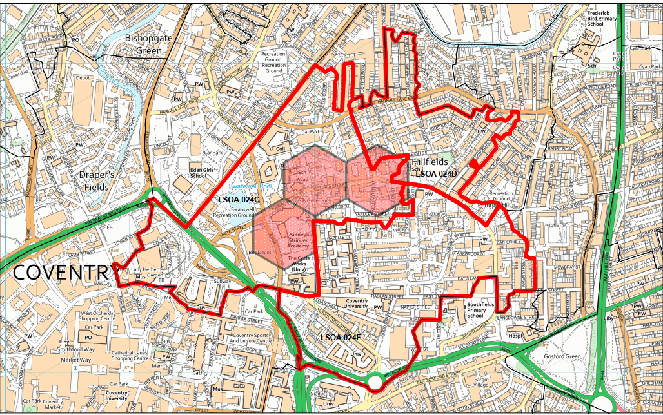
The 3 LSOA areas are within the designated Police “Impact Area.” Impact areas are a West Midlands Police initiative where small areas are chosen based on amount of crime, harm, deprivation and demand. Focussed work within an impact area is about improving quality of life, protecting the most vulnerable and reducing the risk of harm. Force intelligence have further broken down impact areas into smaller priority grids; the grids are just a few streets. Neighbourhood Policing Units use the SARA model to work to solve problems within the grids. Within our chosen area we have 3 of the top five priority grids.

