8 March 2021

Dear Colleagues,

Re: Abuse of retail workers

I write to you on the issue of the abuse of shop workers, and call on you to support the introduction of tougher laws to ensure shop workers are better protected from abuse at work.

Retail workers have worked tirelessly to serve our communities on the frontline of the worst health crisis any of us can remember. Sadly, a growing number of retail workers have had their service and selflessness repaid with abuse; verbal abuse, racism abuse and shockingly physical assaults.

Alex Norris MP’s Assaults on Retail Workers (Offences) Bill, formally introduced in the House of Commons on 16 March 2020, seeks to make an offence of assault, GBH, or ABH aggravated when they are perpetuated against retail workers in the course of their jobs. By making an offence aggravated in the way Alex’s Bill does, retail workers are protected by a robust deterrent that sends a message to would-be offenders that abuse is not acceptable.

I am writing to all West Midlands MPs to urge you to support this Bill on its second reading and to put pressure on the Government to support the Bill. The case for the Bill is simple, and non-contentious: retail workers are the backbone of communities, and they deserve to work free of abuse.

Despite the Bill’s first reading taking place before the first national lockdown was announced, it remains more relevant than ever in light of the pandemic’s role as a major flashpoint for this abuse. In the West Midlands, we have seen a demonstrable rise in assault and incidences of abuse against retail workers. The level of abuse against shop workers in the West Midlands rose by nearly a fifth in 2020, compared to 2019. This matches national findings in the British Retail Consortium’s 2020 Crime Survey, which found that every day, shopworkers are subject to 424 violent or abusive incidents; 155,000 incidents, in total, each year.

After consulting with businesses and retail workers, on whom COVID-19 is already taking a toll, it is clear that retail worker abuse has become a business critical topic. It is outrageous that retail workers jeopardise their own safety when they enforce policies that ensure ours in store, such as mask wearing and compliance with social distancing rules. As part of my commitment to tackle the scourge of shop worker abuse, the West Midlands PCC and I worked quickly last April to introduce an emergency chapter to our Police and Crime Plan, which sought to prioritise, as far as possible, police resources in this direction.

However, it is clear that without a strong legislative deterrent, prioritisation on a local level can only go so far. Clearly, a national issue requires a national legislative response. It is surely time that retail workers - who continue to be on the frontline in the COVID-19 crisis - are afforded enhanced protection. If retail workers are being asked to take on extra duties when enforcing store policies, they must be afforded enhanced legislative protection to do so. They must be reassured that reporting incidents will result in swift and proper punishment for the offender.

Even though a vaccine gives hope for the COVID-19 crisis and the welfare of retail workers, it is clear that a legislative refresh is now long overdue. We must not let up; the Assaults on Retail Workers (Offences) Bill deserves a full hearing in Parliament, and I have called on the Policing Minister Kit Malthouse MP to provide Parliamentary time to ensure that this is so. However, strong cross-party support in bringing forward the Bill’s Second Reading as soon as possible and seeking the support of the Government, will reflect your commitment to the retail workers, who work tirelessly to support our communities.

Retail workers must feel free to work without fear of abuse; it is not, and can never be, part of the job. Against this backdrop, Alex Norris MP’s Bill presents an opportunity to work on a cross-party basis to tackle retail worker abuse. I hope it is an opportunity that you take, and I sincerely hope you are able to support this Bill.

Yours sincerely
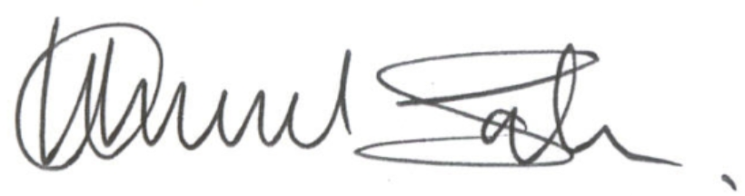

Waheed Saleem
West Midlands Deputy Police and Crime Commissioner

British Retail Consortium, ‘2020 Crime Survey’ (2020) <https://brc.org.uk/news/corporate-affairs/violence-and-abuse-against-shop-workers-spirals/>

