Date: Friday 28th January 2022

Dear FOI Applicant,

Thank you for your freedom of information request received in this office on 4th January 2022 in which you asked:

Could you please provide data you hold regarding Norfolk Hotel, 267 Hagley Rd, edgbaston, Birmingham, B16 9NA. The reason for making this request is because Birmingham City Council have mentioned an ASBO registered against the hotel which we have no knowledge of.

We would also like to have data on the number of call outs recorded to the hotel and neighbouring hotels / B&Bs to analyse crime statics in the area.

In response to your request, I can confirm that the Office of the Police and Crime Commissioner (OPCC) does not hold this information. However, this information may be held by West Midlands Police.

In order to be of some assistance, please see the following contact details should you wish to submit your request to West Midlands Police.

Freedom of Information Unit
West Midlands Police
PO Box 52, Lloyd House
Colmore Circus Queensway
Birmingham
B4 6NQ
E-mail: foi@west-midlands.police.uk

Freedom of Information Right of Appeal

Any person who has requested information from the Office of the Police and Crime Commissioner (OPCC) and is unhappy with the way their request for information has been handled can request a review of their case.

A request for review must be made in writing by letter or email. You should include the reference number of your request if you have it, and outline why you are requesting the review to:

Office of the Police and Crime Commissioner
Lloyd House
Birmingham
B4 6NQ

Telephone: 0121 626 6060
Email: wmpcc@westmidlands.police.uk

All requests for review will be recorded. Receipt of a request for internal review will be acknowledged and the appellant informed of an estimated date for determining the outcome. The OPCC will attempt to respond to internal reviews as soon as practicable and in any case within two months.

All investigations will be undertaken by someone not involved in the original response.

The result of any internal review will be communicated to the appellant outlining the decisions taken.

If you remain dissatisfied with the handling of your request or complaint, you have a right to appeal to the Information Commissioner at:

The Information Commissioner's Office
Wycliffe House
Water Lane
Wilmslow
Cheshire
SK9 5AF

Telephone: 08456 30 60 60 or 01625 54 57 45
Website: www.ico.gov.uk

There is no charge for making a request for internal review or appeal to the Information Commissioner.

Yours sincerely,
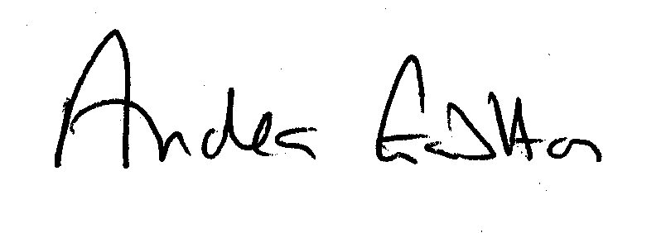
Andrea Gabbitas
Head of Business Services

