Domestic Abuse Perpetrator Interventions Fund - Delivery Specification
_________________________________________________________________________________

Service | Domestic Abuse Perpetrator Interventions.
Commissioning Lead | Alethea Fuller
Period | 1st April 2023- 31st March 2025
Value of Project*  *Subject to the OPCC being awarded the Home Office Domestic Abuse Perpetrator Intervention Fund 2023-25. | Minimum bid value for Lot 1 & 2: £300,000 (per annum)  Maximum bid value for Lot 1 & 2: £1,000,000 (per annum)  Minimum bid value for Lot 3: £300,000 (per annum)  Maximum bid value for Lot 3: £1,000,000 (per annum)

Introduction
A funding opportunity has arisen whereby the Home Office are making available significant funding through the Domestic Abuse Perpetrators Fund. This fund can only be bid into by Police and Crime Commissioners and so we are seeking to secure bidding partners through our own competitive process. The funding that is stated as being available through this opportunity is the Home Office funding that we are bidding into. If applicants are successful in being selected as our bidding partners, this does not itself guarantee funding or contract. Those successful in being selected to be our bidding partner will need to contribute further work in support of developing the bids (the Home Office’s deadline being 17th February) and Home Office guidelines are clear in stating that they cannot cover the costs of bidding and neither will the West Midlands PCC.
This specification has been split into multiple “Lots” outlined below. You can apply for 1 or more Lot, either as a sole provider or as a lead provider in a consortium/partnership. Please note Lot 1 & 2 will be combined by the OPCC in the final bid to the Home Office. The amounts of Lot 1 & 2 should equate to a minimum of £300,000 or a maximum of £1,000,000 COMBINED. Please specify these details along with which LOT you wish to apply to in the attached expression of interest (EOI) application form.
The 3 Lots are as follows:
- Lot 1: Early Responses – In Custody Intervention
- Lot 2: Independent Evaluation of the Early Responses Programme – In Custody Intervention
- Lot 3: Behaviour Change Intervention
The OPCC welcomes applications for multiple Lots (though a separate form will need to be completed for each).
Please complete EOI along with the budget template attached.
The deadline for submissions is 5pm on 3rd February 2023. Please send applications through to Chelsea Lloyd at chelsea.lloyd@westmidlands.police.uk

Background
Over the past 12 months the Office of the Police and Crime Commissioner (OPCC) has been working towards developing a regional approach to managing domestic abuse (DA) perpetrators. This has included the commissioning of academic research, several workshops, consultations and discussions with strategic partners and a region wide conference held in November 2021. Throughout the course of this work the OPCC has sought to develop an understanding of what works when managing DA perpetrators. The work has resulted in the development of four key pillars within which a range of interventions can be developed. These four pillars (ranked in order of priority below) effectively capture the areas of work which we as a region must consider.
- Systems readying
- Behaviour Change Interventions
- Strengthening the Criminal Justice System (CJS) Response
- Prevention & Early Intervention with Children and Young People
Through our work, the OPCC has evidenced a palpable shift in attitudes amongst agencies across the West Midlands compared to when we embarked on the journey of commissioning DAPPs several years ago. There now appears to be a real shared appetite and intention for the implementation of effective, evidence-based interventions and behaviour change to address DA perpetration across the region.
The OPCC is seeking a delivery partner for the following initiatives which have all been designed and developed in consultation with partners.

LOT 1: Early Responses - In Custody Intervention

With the flow of DA perpetrator volume across the West Midlands custody estates and the low percentage of positive outcomes, the OPCC would like to do more to protect our victims from further harm. We know that there is not enough provision across the region currently to change the behaviour of the offenders. Therefore, the onus on protection from further offences tends to be placed on the victim adopting various safety measures as opposed to the perpetrator taking responsibility to address why they commit DA and developing their own understanding as to how they can change their DA offending behaviours with relevant support.
Through this early response ‘in custody’ intervention, the OPCC would like to enhance the work around perpetrators by attempting to identify the issues as to why they offend and to place provision within the custody environment that enables perpetrator engagement and support via a referral to stem future DA offending.
The custody environment offers us a ‘Reachable moment’. The moment of circumstance where a perpetrator is more likely to consider their behaviours and take offers of support. As professionals we should capitalise on these moments, as part of our wider strategy of victim protective measures. A critical opportunity to engage, identify the triggers of offending and offer support via relevant referral to achieve long term sustained change for that perpetrator. The premise of this intervention is to essentially turn that reachable moment into a ‘teachable one’.
The OPCC is seeking a delivery partner who will be able to carry out an independent early conversation with all arrested DA offenders within our custody estates, removed from the investigative process that utilises that reachable moment to try and understand the trigger for that DA offending and to offer support via a referral mechanism to address those DA triggers.
This utilises that reachable moment, turning it into a teachable moment for longer term perpetrator change, prevention of further offending and the protection of vulnerable victims. This intervention will require time to engage with perpetrators within the custody environment, provide impartiality and the skills/training needed on how best to communicate and engage with these individuals.
We expect the provider to work alongside West Midlands Police to ensure appropriate service provision as well as appropriate service delivery model to meet demand; taking into consideration factors such as number of hours, number of staff and shift patterns.
We expect the provider to cover all 4 Custody blocks within the West Midlands.
- Oldbury Custody Block
- Perry Barr Custody Block
- Billston Street Custody Block
- Little Park Street Custody Block
Providers may use the data below to work out coverage:
Year to date 35,812 crimes of Domestic Abuse (DA) have been recorded with only 1532 positive outcomes. This equates to 4.36% outcome rate. (*Data 30/09/22). This does not represent the force well in how it brings offenders to justice, and how it safeguards its victims.

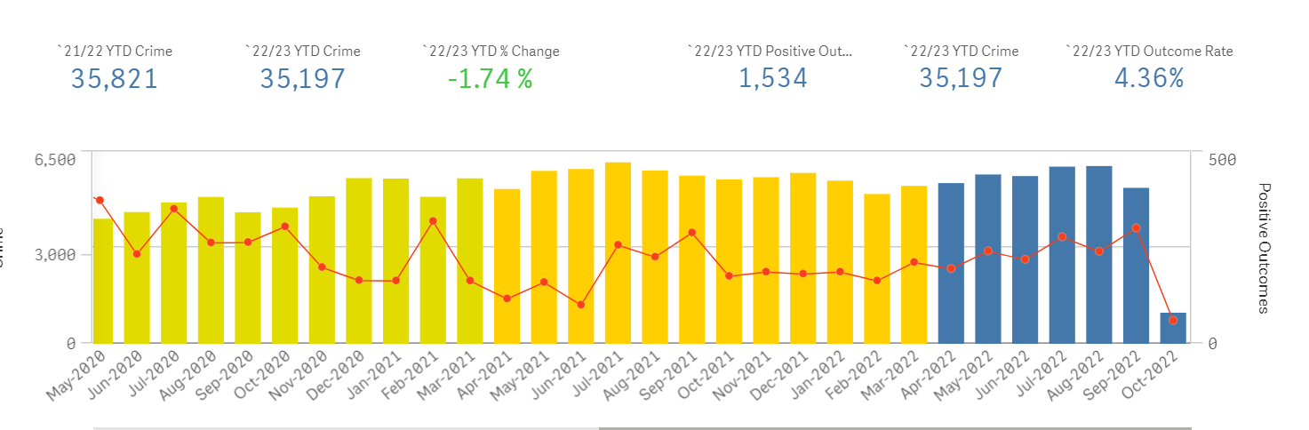
This equates to 6395 DA Adult offenders arrested and being dealt with within WMP custody blocks
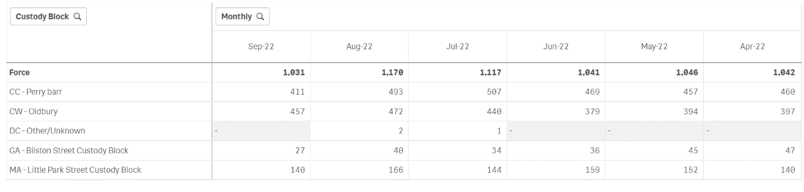
The greater volume being at Perry Barr ( 2797) and Oldbury ( 2539).
When Voluntary interviews of Adult DA offenders are taken into consideration this adds a further volume of 449, with greater volume at Perry Barr ( 121 ) and Oldbury ( 237).
Vol interviews ( DA + Adult )
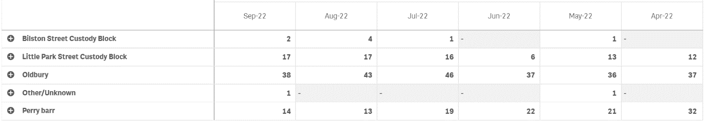
Since April 2022, this is 6844 DA offenders in a custody environment that could have realised a positive outcome.

Expected outcomes of the ‘In Custody’ intervention – Proposed Performance Metrics for Evaluation
- Increased perpetrator understanding and awareness of domestic abuse
- Increased avenues for victim safeguarding
- Increased positive engagement of DA perpetrators into supportive DA programmes.
- Increased understanding of co-occurring issues alongside DA offending to inform future planning/commissioning/ required pathways
- Increased number of referrals to DA programmes and support services
- Increased positive outcomes for DA crimes and Increase use of OOCD routes
- Prevention of re-offending and repeat DA

Integrated Victim Support
It is imperative that victim safeguarding is an integral feature of this in custody intervention and it is crucial that accountability sits firmly with those perpetrating domestic abuse and that victims and children – now recognised as victims in their own right – are adequately safeguarded and supported to cope and recover without the expectation to ‘keep themselves safe.’ Whilst perpetrator interventions have an important role to play in this context, we believe all agencies involved with individuals/families experiencing or perpetrating domestic abuse have a responsibility to ensure that professionals are adequately trained to recognise and appropriately respond to both victims and perpetrators of domestic abuse in a trauma-response and anti-victim blaming manner.
Therefore, as part of this intervention we are seeking a victim support service to be embedded within the in-custody intervention. This can be either:
- Delivered in partnership with specialist victims’ support services.
- Delivered by your own organisation. If it is to be delivered in house, you must be able to demonstrate how you will robustly risk manage each case ensuring the safety and security of victims and children.
- To avoid any doubt, the perpetrator worker and victim support worker MUST NOT be the same person.
All providers must have appropriate information sharing mechanisms in place to avoid any escalation of further risk to the victim.
Expected Outcomes – Proposed Performance Metrics for Evaluation
- Improved victim safeguarding and support.
- Reduced re-offending rates amongst perpetrators.
- Reduction of physical violence.
- Respectful relationships.
- Expanded space for action (the ability of victim/survivors to restore agency and freedom safely from abuse).
- Decreased isolation.
- Enhanced parenting.
- Understanding the impact of domestic violence.
Children’s social care
A desired element of the bid would be that there is an embedded social worker who is co-located within custody and can liaise with both the perpetrator worker and victim support worker.
The OPCC are keen to work with the chosen provider to establish this long-term aspiration.

LOT 2 - Independent Evaluation of the Early Responses Programme

The OPCC is seeking a partner to deliver an independent evaluation of the ‘In Custody Intervention’ which is outlined in Lot 1. For more details on the project please see information provided earlier in the document.
This intervention is a pilot project which will be covering the 4 Custody blocks within the West Midlands.
- Oldbury Custody Block
- Perry Barr Custody Block
- Billston Street Custody Block
- Little Park Street Custody Block
The OPCC would like to understand the success, challenges and learnings from the project across the two years it will be in place. The evaluation should comprise of the following:
Year 1
- The number of perpetrators who received the intervention in custody.
- The number of perpetrators who volunteered to take part in a follow-on perpetrator programme or intervention for existing provision that is available.
- Whether the referral pathways into each local authority area is appropriate and effective.
- The satisfaction levels of the perpetrator and their feedback on the intervention.
- The satisfaction levels of the victim and their feedback on the intervention.
- Recommendations on service improvements for year 2.
Year 2
- The number of perpetrators who received the intervention in custody.
- The number of perpetrators who volunteered to take part in a follow-on perpetrator programme or intervention for existing provision that is available.
- Whether the referral pathways into each local authority area is appropriate and effective.
- The satisfaction levels of the perpetrator and their feedback on the intervention.
- The satisfaction levels of the victim and their feedback on the intervention.
- Recommendations on service improvement
- Whether the service can be embedded in the West Midlands following the end of the Home Office funding.
For this Lot, applicants may use their own template to apply to the OPCC.

LOT 3: Behaviour Change Intervention

In December 2020, the Office of the West Midlands Police and Crime Commissioner in partnership with Cordis Bright was successful in its submission to the Home Office. The research looked at ‘Evidence on What Works with Domestic Abuse Perpetrators and was intended to act as a basis to further explore ‘what works’; adding to the evidence base for the most effective way(s) to address perpetrator behaviour and keep victims safe in the West Midlands and understand the most effective commissioning of DA perpetrator interventions.
The key areas of exploration were:
- Understanding the level of need across the West Midlands for interventions that work with perpetrators to prevent further harm;
- Understanding the level of existing provision and whether this meets the level of need across the West Midlands;
- The characteristics of successful programmes, services, and initiatives which address the abuse and violence of perpetrators;
- Understanding what types of evidence are needed to support the commissioning of interventions and approached that reduce the domestic abuse of perpetrators.
The research found in terms of the suggested model and format of domestic abuse perpetrator programmes (DAPPs), the evidence regarding ‘what works’ is limited and/or contested. Whether perpetrator’s participation should be voluntary, mandatory or conditional is contested in literature and amongst stakeholders, as is the length, intensity and format of programmes and Cordis Bright conclude that further evidence is needed on the impact of each respective method to support commissioning and funding decisions in this respect.
However, through our engagement with stakeholders there was agreement that DAPPs ought to be local and accessible with facilitators representative of the communities they work with and designed to reflect and meet the needs of the communities they serve with specific regard to protected characteristics, where possible. Through our regional consultation we have been told that Intervention(s) should take a trauma-informed approach. There should be holistic provision available locally that can be accessed by perpetrators, victims/survivors and children. All service users, regardless of their protective characteristics, should have access to interventions/support and any language or other needs addressed to ensure accessibility. Our consultative work has suggested that there should be a key worker model and advocacy whereby there is a team and plan around the perpetrator to address the behaviour (‘TAP’). Within this there should be specialism, joint-working, risk management and identification and work force development and flexibility of the delivery model. The behaviour change within such an approach should be 1:1, have a multi risk assessment, apply Maslow’s hierarchy of needs and address drugs, alcohol and health.
In summary it has been suggested to the OPCC that a service should address multi-faceted need appropriately; being able to address different typologies, level of risk and victim involvement. It should be a whole-systems, whole family, wrap around service which links with substance misuse, mental health, children’s services, Police, MARAC & ODOC, education and housing. There should always be parallel services for victims and children and mechanisms to ensure the voice and safety of victims and children are central. It was suggested that there should be a lead provider model with specialist integrated but independent victim services.
Following on from the above research and from the OPCC’s extensive regional consultation on DAPPs we seek the provision of an integrated Domestic Abuse Perpetrator Programme (DAPP). In the first instance, the referral pathway will solely come from the In-Custody Intervention. The OPCC will assess the numbers of referrals and potentially widen this out to allow for additional agencies to refer in later. The Behaviour Intervention MUST:
- Meets Home Office or Respect standards
- Include a motivation to change intervention prior to the perpetrator engaging in the behaviour change intervention
- The intervention must run alongside an integrated victim support provision. This can be done as a sole provider or as a lead provider in a consortium/partnership.
- The intervention must take into consideration the Equalities Act 2010
- The intervention must have clear outcomes and metrics
- The intervention must provide a Theory of Change
This DAPP is being sought on a spot purchase basis and must be deliverable across all 7 local authority areas.

Requirements

Applications must adhere to;
- Home Office Domestic Abuse Perpetrator Standards
- Respect Domestic Abuse Perpetrator standards

Conclusion

You can apply for 1 or more Lot, either as a sole provider or as a lead provider in a consortium/partnership. Please note Lot 1 & 2 will be combined by the OPCC in the final bid to the Home Office. The amounts of Lot 1 & 2 should equate to a minimum of £300,000 or a maximum of £1,000,000 COMBINED. Please specify these details along with which LOT you wish to apply to in the attached expression of interest (EOI) application form.
The 3 Lots are as follows:
1.) Lot 1: Early Responses – In Custody Intervention
2.) Lot 2: Independent Evaluation of the Early Responses Programme - In Custody Intervention
3.) Lot 3: Behaviour Change Intervention
The OPCC welcomes applications for multiple Lots (though a separate form will need to be completed for each).
Please complete EOI along with the budget template attached.
The deadline for submissions is 5pm on 3rd February 2023. Please send applications through to Chelsea Lloyd at chelsea.lloyd@westmidlands.police.uk

https://www.cordisbright.co.uk/news/evidence-on-what-works-with-domestic-abuse-perpetrators
Standards for domestic absue perpetrator interventions (publishing.service.gov.uk)
Respect_Standard_4th_edition_2022.pdf (hubble-live-assets.s3.amazonaws.com)

