Second Chances Charter
Easy Read
Explanations
 | People with convictions includes people who have been to prison, people on probation and/or people who have been charged with a crime.
About the Second Chances Charter
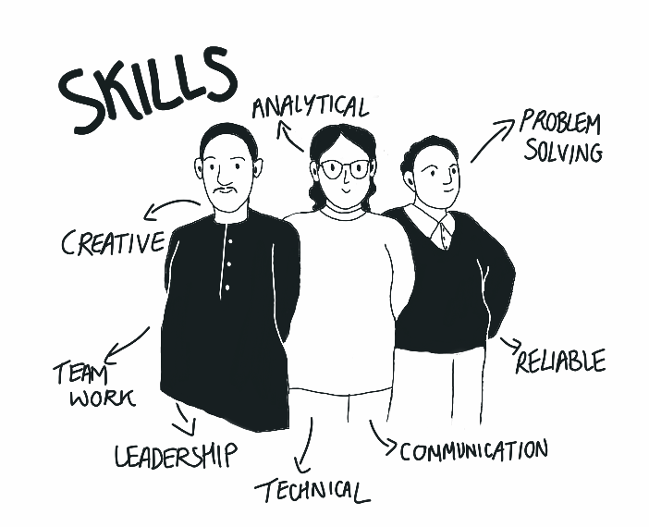 | We know that people with convictions have lots of valuable skills and want to work but they often get treated badly by organisations when trying to get a job.
 | We have created the Second Chances Charter to help to reduce the problems people face in getting work and to change the bad ideas organisations have about giving a job to someone with convictions.
 | The Second Chances Charter is an agreement that organisations sign to help to reduce the problems that people face when trying to get work when they have convictions.
What does the Second Chances Charter say?
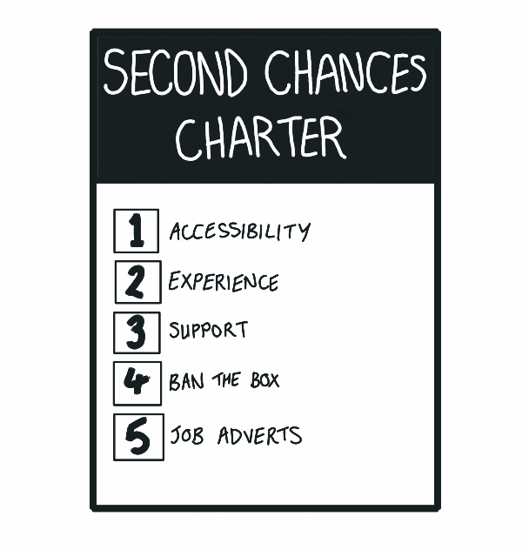 | The Second Chances Charter says 5 things that organisations need to do:
 | - Make jobs more accessible with guaranteed interviews and entry-level jobs.
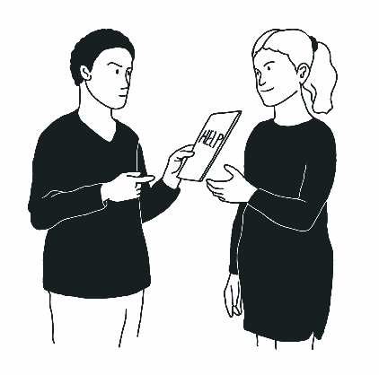 | - Help people gain experience by giving work experience. For those in a job mentors, trainers and support should be provided.
 | - Give practical support to the people who start working with them. This could be with a bus pass or flexible working hours.
 | - Think about banning the box on application forms
 | - Put Second Chances Charter on job adverts
What help we can give
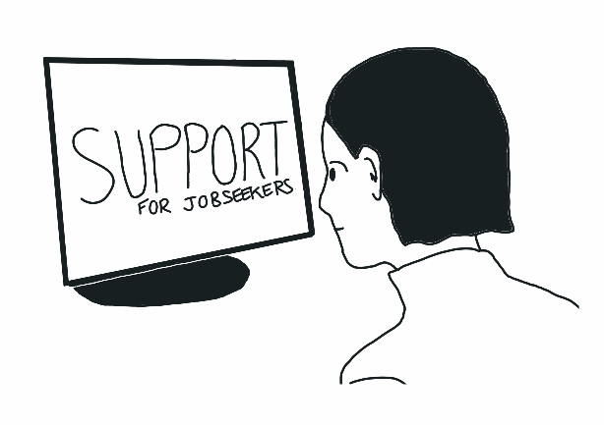 | Help is available on the website under the ‘support for jobseeker’ section’, for example with housing, mental health support

